CHAPTER 18

MODELS FOR TIME SERIES AND FORECASTING

SECTION EXERCISES
18.1 d/p/e The four components of a time series are: (1) trend, an overall upward or downward tendency, (2) cycle, a periodic fluctuation that repeats over time, (3) seasonality, a periodic fluctuation that repeats over a period of a year or less, and (4) irregularity, random fluctuations resulting from chance events.

18.2 d/p/m (a) seasonal fluctuation, (b) cyclical fluctuation, (c) irregular fluctuation.

18.3 p/a/e The water consumed during the month is y = 400,000*1.20*0.70*1.10 = 369,600 gallons.

18.4 p/a/e If x = 1 for 1995, then x = 18 for 2012. Therefore the forecast for industry worker-days lost due to job-related injuries in 2012 is = 1200 + 35(18) = 1830.

18.5 p/a/m The Minitab printout and plot are shown below.

Regression Analysis: Earnings versus YearCode

The regression equation is Earnings = 15.0 + 0.582 YearCode

Predictor Coef SE Coef T P
Constant 15.0450 0.1002 150.19 0.000
YearCode 0.58200 0.03658 15.91 0.004

S = 0.0817924 R-Sq = 99.2% R-Sq(adj) = 98.8%

Analysis of Variance
Source DF SS MS F P
Regression 1 1.6936 1.6936 253.16 0.004
Residual Error 2 0.0134 0.0067
Total 3 1.7070

Predicted Values for New Observations
New
Obs Fit SE Fit 95% CI 95% PI
1 20.8650 0.2774 (19.6716, 22.0584) (19.6208, 22.1092)XX
XX denotes a point that is an extreme outlier in the predictors.

Values of Predictors for New Observations
New
Obs YearCode
1 10.0
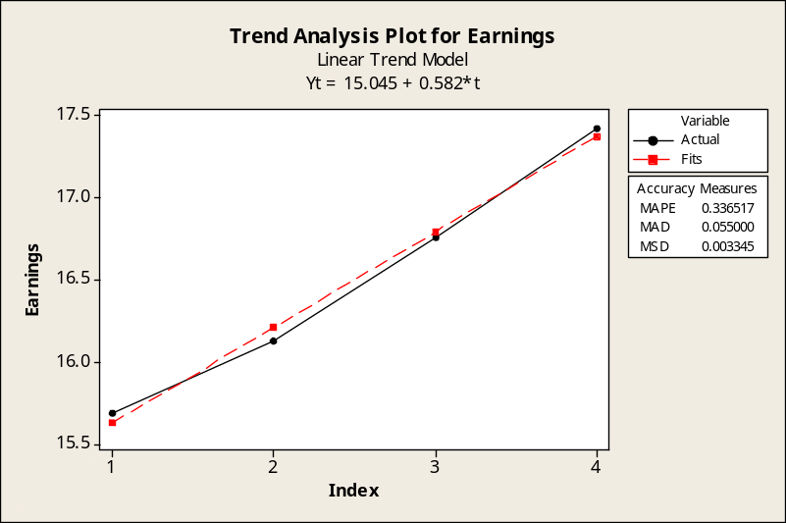

With x = the year code and x = 1 for 2004, the trend equation is Earnings = 15.045 + 0.582x. For 2013,
x = 10 and the estimated wage for 2013 is 15.045 + 0.582(10) = $20.865. Also see the "Fit" portion of the printout. The Excel counterpart is shown below. Recall that Excel reverses the positions of the constant and the coefficient term compared to the more common format used in the textbook and by Minitab.
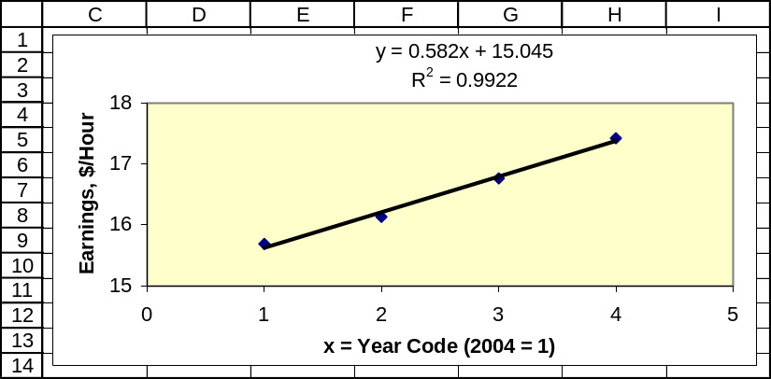

18.6 p/a/m The Minitab printout and plot are shown below.

Regression Analysis: Ships versus YearCode
The regression equation is Ships = 492 + 18.9 YearCode

Predictor Coef SE Coef T P
Constant 491.75 11.03 44.60 0.001
YearCode 18.900 4.026 4.69 0.043

S = 9.00250 R-Sq = 91.7% R-Sq(adj) = 87.5%

Analysis of Variance
Source DF SS MS F P
Regression 1 1786.1 1786.1 22.04 0.043
Residual Error 2 162.1 81.0
Total 3 1948.1

Predicted Values for New Observations
New
Obs Fit SE Fit 95% CI 95% PI
1 718.55 38.51 (552.85, 884.25) (548.38, 888.72)XX
XX denotes a point that is an extreme outlier in the predictors.

Values of Predictors for New Observations
New
Obs YearCode
1 12.0
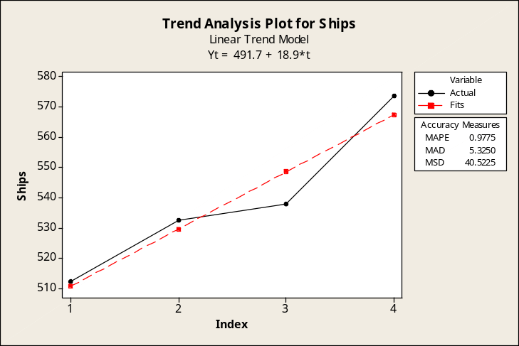
With x = the year code and x = 1 for 2004, the trend equation is Ships = 491.75 + 18.90x. For 2015,
x = 12 and the estimated shipment value for 2015 is 491.75 + 18.90(12) = $718.55 billion. Also see the "Fit" portion of the printout. The Excel counterpart is shown below.
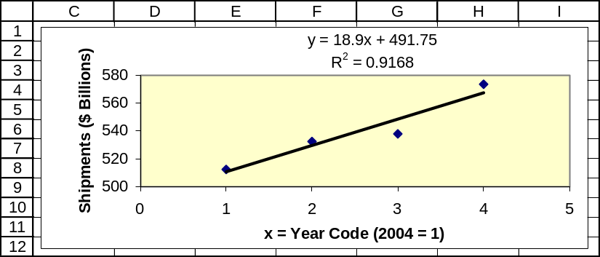

18.7 p/c/d
a. A portion of the Minitab printout is shown below, along with the plot. In this time series,
1996 is period 1 and 2013 is period 18. With x = the year code, the trend equation is
Subs = 13.371 + 19.357x and the estimate for 2013 is 13.371 + 19.357(18) = 361.8 million.

Regression Analysis: Subs versus YearCode
The regression equation is Subs = 13.4 + 19.4 YearCode

Predictor Coef SE Coef T P
Constant 13.371 4.325 3.09 0.011
YearCode 19.3570 0.5877 32.94 0.000

S = 7.02769 R-Sq = 99.1% R-Sq(adj) = 99.0%

...

Predicted Values for New Observations
New
Obs Fit SE Fit 95% CI 95% PI
1 361.80 7.06 (346.07, 377.52) (339.61, 383.99)XX
XX denotes a point that is an extreme outlier in the predictors.

Values of Predictors for New Observations
New
Obs YearCode
1 18.0
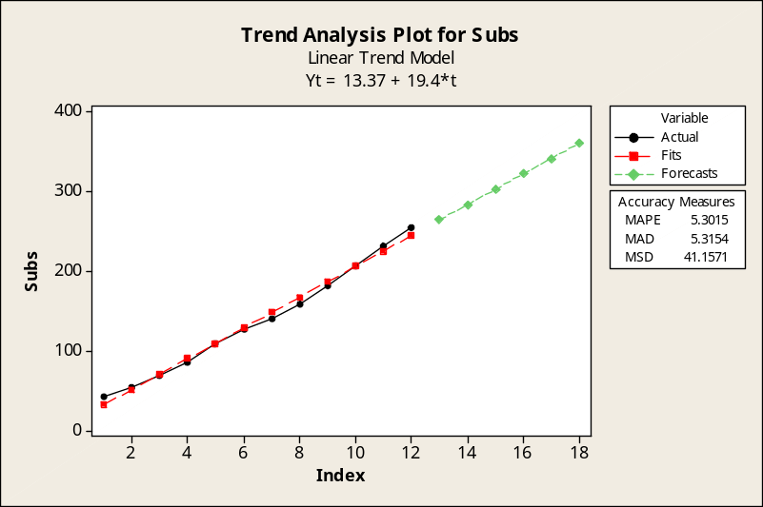

b. The Minitab printout is shown below, along with the plot. In this time series,
1996 is period 1 and 2013 is period 18. With x = the year code, the trend equation is
Subs = 29.993 + 12.233x + 0.54798x². The estimate for 2013 can be calculated as
29.993 + 12.233(18) + 0.54798(18)² = 427.7 million subscribers.

Regression Analysis: Subs versus YearCode, YearCode_sq

The regression equation is Subs = 30.0 + 12.2 YearCode + 0.548 YearCode_sq

Predictor Coef SE Coef T P
Constant 29.993 3.324 9.02 0.000
YearCode 12.233 1.176 10.40 0.000
YearCode_sq 0.54798 0.08804 6.22 0.000

S = 3.21649 R-Sq = 99.8% R-Sq(adj) = 99.8%

Analysis of Variance
Source DF SS MS F P
Regression 2 53982 26991 2608.87 0.000
Residual Error 9 93 10
Total 11 54075

Predicted Values for New Observations
New
Obs Fit SE Fit 95% CI 95% PI
1 427.737 11.076 (402.682, 452.792) (401.647, 453.827)XX
XX denotes a point that is an extreme outlier in the predictors.

Values of Predictors for New Observations
New
Obs YearCode YearCode_sq
1 18.0 324
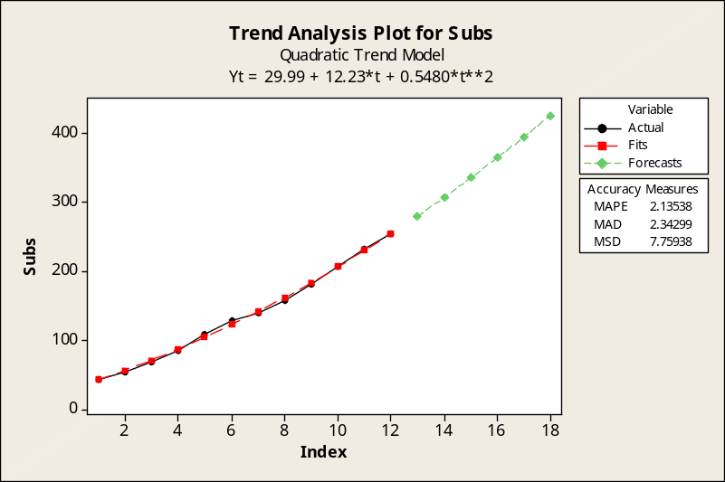

c. Based on the graphs shown in parts a and b, as well as the multiple plot shown below, the quadratic equation (part b) is the better fit to the data.
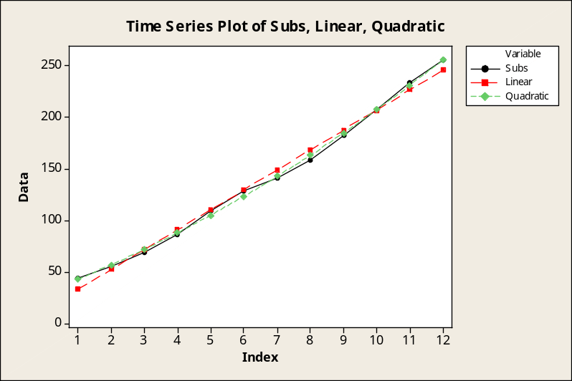

The Excel counterparts to the equations in parts a and b are shown below.
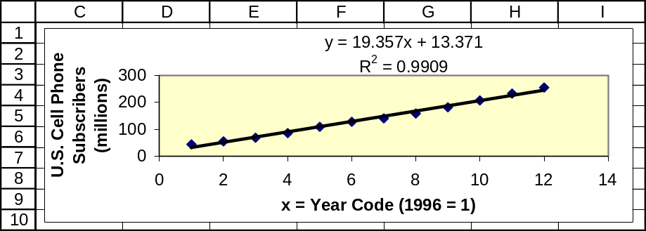
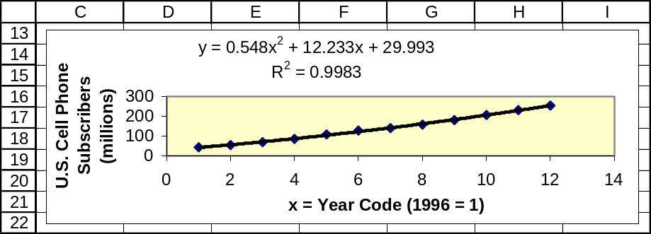

18.8 p/c/d
a. The Minitab printout is shown below, along with the plot. In this time series,
2000 is period 1 and 2015 is period 16. With x = the year code, the trend equation is
Exports = 91.143 + 4.99x and the estimate for 2015 is 91.143 + 4.99(16) = $171.0 billion.

Regression Analysis: Exports versus YrCode

The regression equation is Exports = 91.1 + 4.99 YrCode

Predictor Coef SE Coef T P
Constant 91.143 7.848 11.61 0.000
YrCode 4.990 1.554 3.21 0.018

S = 10.0724 R-Sq = 63.2% R-Sq(adj) = 57.1%

Analysis of Variance

Source DF SS MS F P
Regression 1 1046.0 1046.0 10.31 0.018
Residual Error 6 608.7 101.5
Total 7 1654.7

Predicted Values for New Observations
New
Obs Fit SE Fit 95% CI 95% PI
1 170.99 18.22 (126.40, 215.58) (120.04, 221.94)XX
XX denotes a point that is an extreme outlier in the predictors.

Values of Predictors for New Observations
New
Obs YrCode
1 16.0

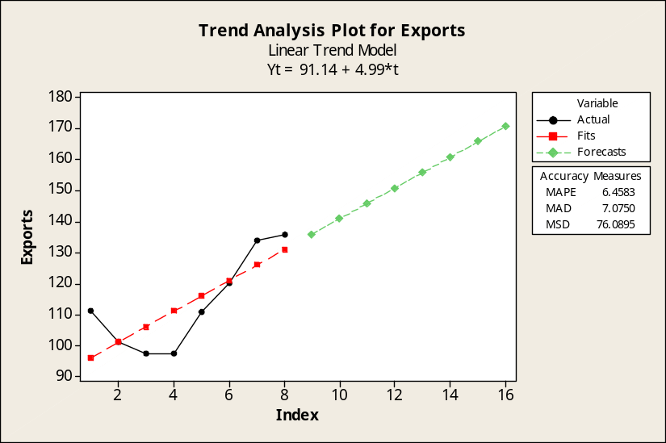

b. The Minitab printout is shown below, along with the plot. With x = the year code and x = 1 for 2000, the trend equation is Exports = 115.464 - 9.602x + 1.6214x². The estimate for 2015 can be calculated as 115.464 - 9.602(16) + 1.6214(16)² = $376.9 billion.

Regression Analysis: Exports versus YrCode, YrCode_sq

The regression equation is Exports = 115 - 9.60 YrCode + 1.62 YrCode_sq

Predictor Coef SE Coef T P
Constant 115.464 8.064 14.32 0.000
YrCode -9.602 4.111 -2.34 0.067
YrCode_sq 1.6214 0.4459 3.64 0.015

S = 5.77995 R-Sq = 89.9% R-Sq(adj) = 85.9%

Analysis of Variance
Source DF SS MS F P
Regression 2 1487.68 743.84 22.27 0.003
Residual Error 5 167.04 33.41
Total 7 1654.72

Unusual Observations
Obs YrCode Exports Fit SE Fit Residual St Resid
8 8.00 136.10 142.42 4.86 -6.32 -2.02R
R denotes an observation with a large standardized residual.

Predicted Values for New Observations
New
Obs Fit SE Fit 95% CI 95% PI
1 376.91 57.59 (228.87, 524.95) (228.13, 525.70)XX
XX denotes a point that is an extreme outlier in the predictors.

Values of Predictors for New Observations
New
Obs YrCode YrCode_sq
1 16.0 256

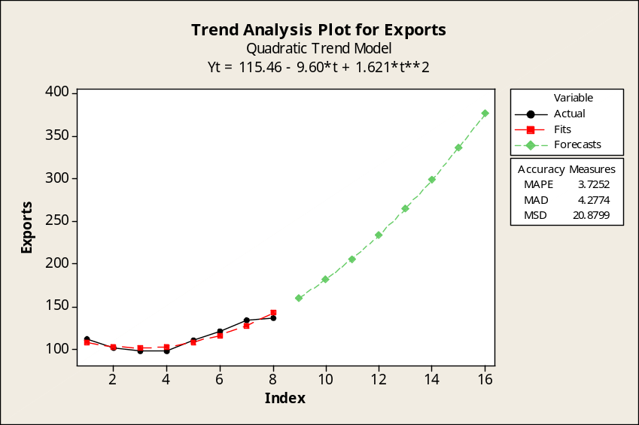

c. Based on the graphs shown in parts a and b, as well as the multiple plot shown below, the quadratic equation (part b) is a much better fit to the historic data.
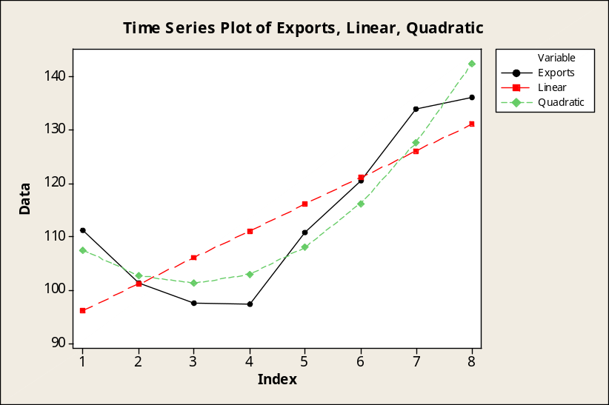

The Excel counterparts to the equations in parts a and b are shown below.
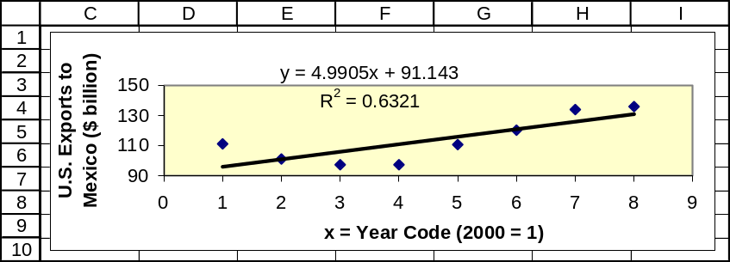
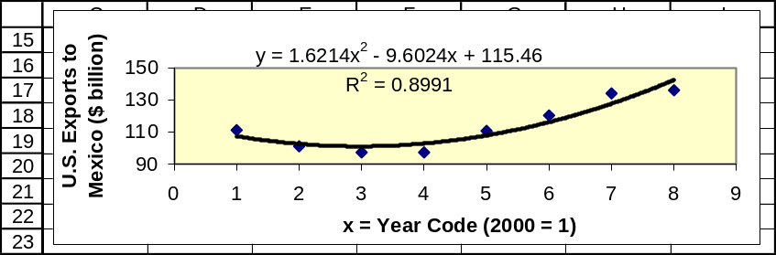

18.9 p/a/m
a. Using Excel to generate and graph the 3-year moving average.
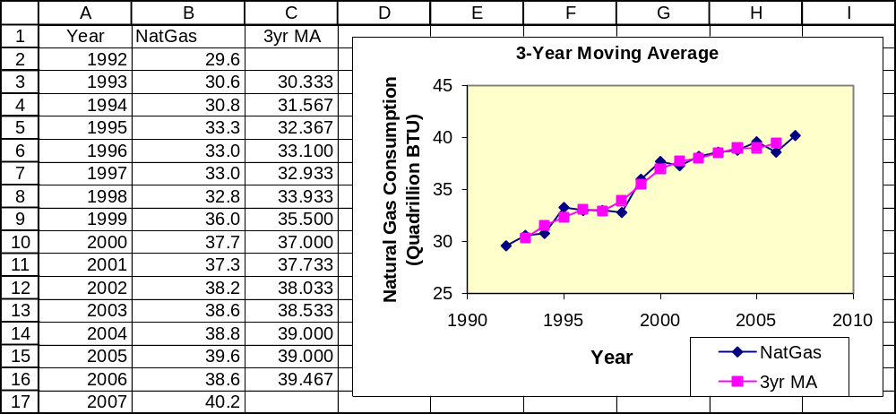

b. Using Excel to generate and graph the 5-year moving average. The moving average is slightly
"smoother" when N = 5 because a larger base provides greater damping.
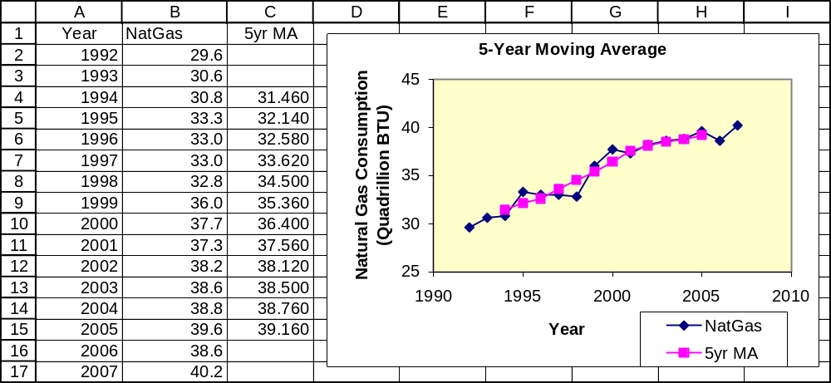

18.10 p/a/m Using Minitab, a portion of the printout and the plot for the centered moving average
with N = 2. Refer to the "MA" column for the centered moving average values.

Moving Average for NatGas

Moving Average Length 2

Time NatGas MA Predict Error
1 29.6 * * *
2 30.6 30.400 30.400 0.200
3 30.8 31.375 31.375 -0.575
4 33.3 32.600 32.600 0.700
5 33.0 33.075 33.075 -0.075
6 33.0 32.950 32.950 0.050
7 32.8 33.650 33.650 -0.850
8 36.0 35.625 35.625 0.375
9 37.7 37.175 37.175 0.525
10 37.3 37.625 37.625 -0.325
11 38.2 38.075 38.075 0.125
12 38.6 38.550 38.550 0.050
13 38.8 38.950 38.950 -0.150
14 39.6 39.150 39.150 0.450
15 38.6 39.250 39.250 -0.650
16 40.2 * 39.250 0.950

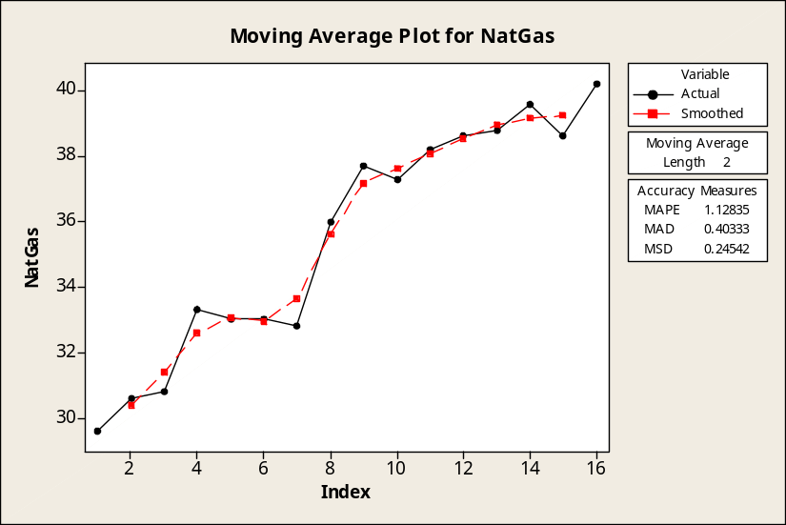

Using Minitab, a portion of the printout and the plot for the centered moving average with N = 4.
Refer to the "MA" column for the centered moving average values.

Moving Average for NatGas

Moving Average Length 4

Time NatGas MA Predict Error
1 29.6 * * *
2 30.6 * * *
3 30.8 31.5000 * *
4 33.3 32.2250 31.5000 1.8000
5 33.0 32.7750 32.2250 0.7750
6 33.0 33.3625 32.7750 0.2250
7 32.8 34.2875 33.3625 -0.5625
8 36.0 35.4125 34.2875 1.7125
9 37.7 36.6250 35.4125 2.2875
10 37.3 37.6250 36.6250 0.6750
11 38.2 38.0875 37.6250 0.5750
12 38.6 38.5125 38.0875 0.5125
13 38.8 38.8500 38.5125 0.2875
14 39.6 39.1000 38.8500 0.7500
15 38.6 * 39.1000 -0.5000
16 40.2 * 39.1000 1.1000

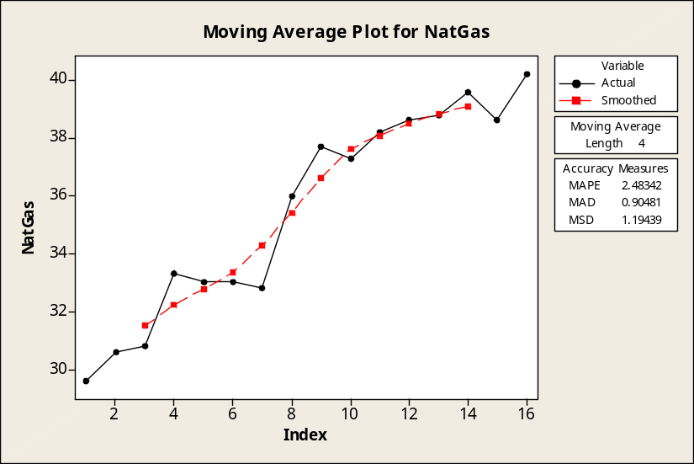

18.11 p/a/m The underlying data, along with the 3-month and 5-month moving averages, are shown in the Excel printout below. The overall trend appears to be very slightly downward.
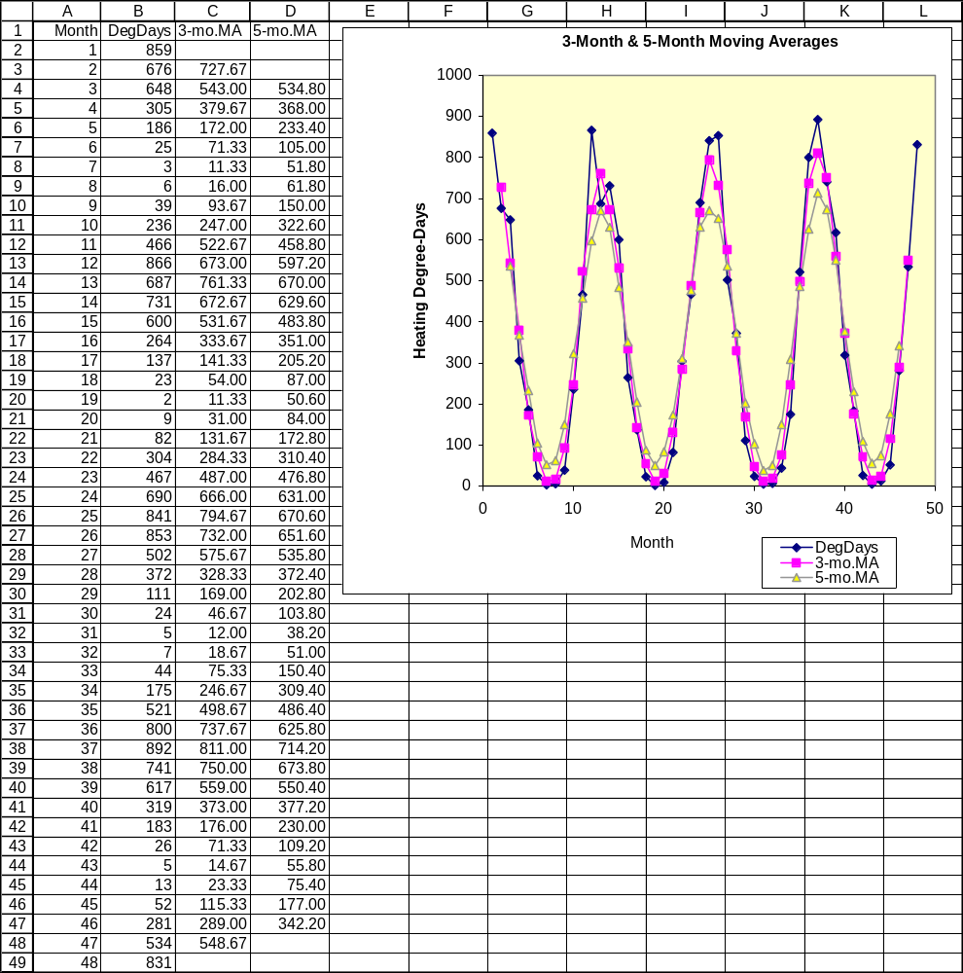

18.12 p/a/m
a. Partial Minitab printouts and the plots for centered moving averages with N = 4 and N = 12.
Refer to the "MA" column for the centered moving average values.

Centered moving average with N = 4.

Moving Average for DegDays

Moving Average Length 4

Time DegDays MA Predict Error
1 859 * * *
2 676 * * *
3 648 537.875 * *
4 305 372.375 537.875 -232.875
5 186 210.375 372.375 -186.375
6 25 92.375 210.375 -185.375
7 3 36.625 92.375 -89.375
8 6 44.625 36.625 -30.625
9 39 128.875 44.625 -5.625
10 236 294.250 128.875 107.125
11 466 482.750 294.250 171.750
12 866 625.625 482.750 383.250
13 687 704.250 625.625 61.375
14 731 645.750 704.250 26.750
15 600 501.750 645.750 -45.750
16 264 344.500 501.750 -237.750
17 137 181.250 344.500 -207.500
18 23 74.625 181.250 -158.250
19 2 35.875 74.625 -72.625
20 9 64.125 35.875 -26.875
21 82 157.375 64.125 17.875
22 304 300.625 157.375 146.625
23 467 480.625 300.625 166.375
24 690 644.125 480.625 209.375
25 841 717.125 644.125 196.875
26 853 681.750 717.125 135.875
27 502 550.750 681.750 -179.750
28 372 355.875 550.750 -178.750
29 111 190.125 355.875 -244.875
30 24 82.375 190.125 -166.125
31 5 28.375 82.375 -77.375
32 7 38.875 28.375 -21.375
33 44 122.250 38.875 5.125
34 175 285.875 122.250 52.750
35 521 491.000 285.875 235.125
36 800 667.750 491.000 309.000
37 892 750.500 667.750 224.250
38 741 702.375 750.500 -9.500
39 617 553.625 702.375 -85.375
40 319 375.625 553.625 -234.625
41 183 209.750 375.625 -192.625
42 26 95.000 209.750 -183.750
43 5 40.375 95.000 -90.000
44 13 55.875 40.375 -27.375
45 52 153.875 55.875 -3.875
46 281 322.250 153.875 127.125
47 534 * 322.250 211.750
48 831 * 322.250 508.750

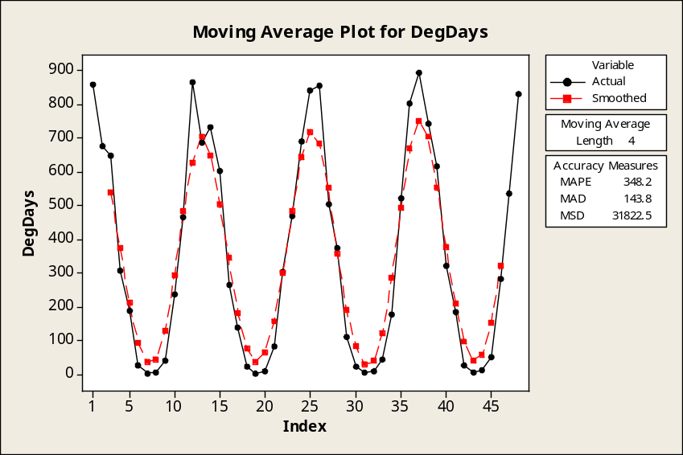

Centered moving average with N = 12.

Moving Average for DegDays

Moving Average Length 12

Time DegDays MA Predict Error
1 859 * * *
2 676 * * *
3 648 * * *
4 305 * * *
5 186 * * *
6 25 * * *
7 3 352.417 * *
8 6 347.542 * *
9 39 347.833 * *
10 236 344.125 * *
11 466 340.375 * *
12 866 338.250 352.417 513.583
13 687 338.125 347.542 339.458
14 731 338.208 347.833 383.167
15 600 340.125 344.125 255.875
16 264 344.750 340.375 -76.375
17 137 347.625 338.250 -201.250
18 23 340.333 338.125 -315.125
19 2 339.417 338.208 -336.208
20 9 350.917 340.125 -331.125
21 82 351.917 344.750 -262.750
22 304 352.333 347.625 -43.625
23 467 355.750 340.333 126.667
24 690 354.708 339.417 350.583
25 841 354.875 350.917 490.083
26 853 354.917 351.917 501.083
27 502 353.250 352.333 149.667
28 372 346.292 355.750 16.250
29 111 343.167 354.708 -243.708
30 24 350.000 354.875 -330.875
31 5 356.708 354.917 -349.917
32 7 354.167 353.250 -346.250
33 44 354.292 346.292 -302.292
34 175 356.875 343.167 -168.167
35 521 357.667 350.000 171.000
36 800 360.750 356.708 443.292
37 892 360.833 354.167 537.833
38 741 361.083 354.292 386.708
39 617 361.667 356.875 260.125
40 319 366.417 357.667 -38.667
41 183 371.375 360.750 -177.750
42 26 373.208 360.833 -334.833
43 5 * 361.083 -356.083
44 13 * 361.667 -348.667
45 52 * 366.417 -314.417
46 281 * 371.375 -90.375
47 534 * 373.208 160.792
48 831 * 373.208 457.792

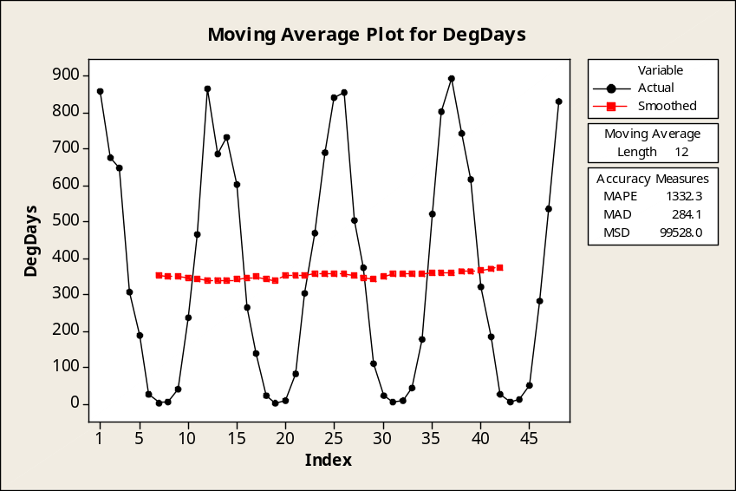

b. The centered moving average with N = 12 is much smoother because it is based on more months,
and also because these data tend to be seasonal with a peak-to-peak period of 12 months.

18.13 p/a/m
a. The overall trend is upward. b. The time series and the two centered moving averages are below.
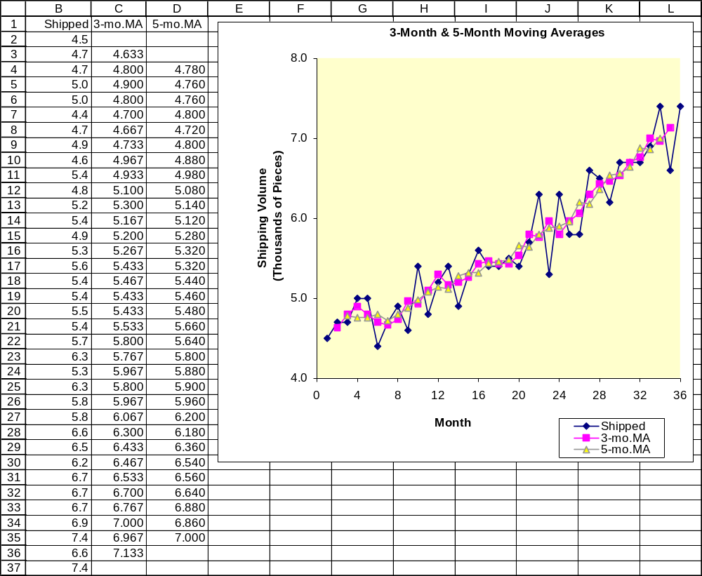

18.14 p/a/m
a. Partial Minitab printouts and the plots for centered moving averages with N = 4 and N = 12.
Refer to the "MA" column for the centered moving average values.

Centered moving average with N = 4.

Moving Average for Pieces

Moving Average Length 4

Time Pieces MA Predict Error
1 4.5 * * *
2 4.7 * * *
3 4.7 4.7875 * *
4 5.0 4.8125 4.7875 0.2125
5 5.0 4.7750 4.8125 0.1875
6 4.4 4.7625 4.7750 -0.3750
7 4.7 4.7000 4.7625 -0.0625
8 4.9 4.7750 4.7000 0.2000
9 4.6 4.9125 4.7750 -0.1750
10 5.4 4.9625 4.9125 0.4875
11 4.8 5.1000 4.9625 -0.1625
12 5.2 5.1375 5.1000 0.1000
13 5.4 5.1375 5.1375 0.2625
14 4.9 5.2500 5.1375 -0.2375
15 5.3 5.3000 5.2500 0.0500
16 5.6 5.3625 5.3000 0.3000
17 5.4 5.4500 5.3625 0.0375
18 5.4 5.4500 5.4500 -0.0500
19 5.5 5.4625 5.4500 0.0500
20 5.4 5.6125 5.4625 -0.0625
21 5.7 5.7000 5.6125 0.0875
22 6.3 5.7875 5.7000 0.6000
23 5.3 5.9125 5.7875 -0.4875
24 6.3 5.8625 5.9125 0.3875
25 5.8 5.9625 5.8625 -0.0625
26 5.8 6.1500 5.9625 -0.1625
27 6.6 6.2250 6.1500 0.4500
28 6.5 6.3875 6.2250 0.2750
29 6.2 6.5125 6.3875 -0.1875
30 6.7 6.5500 6.5125 0.1875
31 6.7 6.6625 6.5500 0.1500
32 6.7 6.8375 6.6625 0.0375
33 6.9 6.9125 6.8375 0.0625
34 7.4 6.9875 6.9125 0.4875
35 6.6 * 6.9875 -0.3875
36 7.4 * 6.9875 0.4125

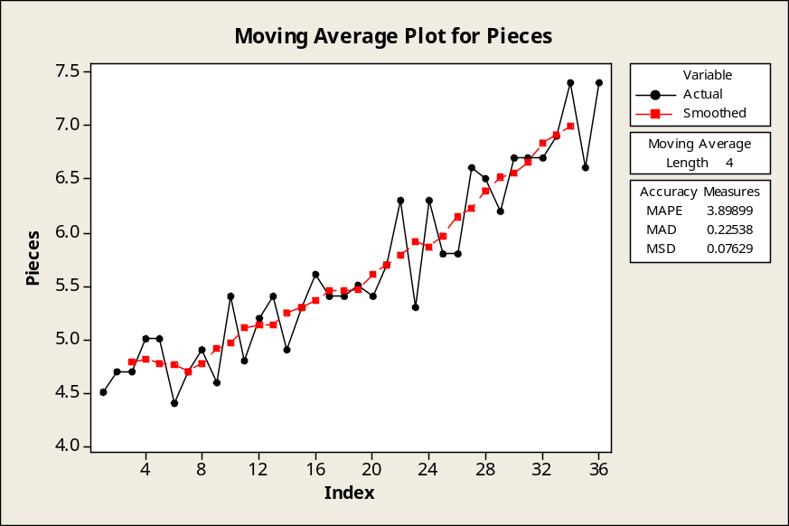

Centered moving average with N = 12.

Moving Average for Pieces

Moving Average Length 12

Time Pieces MA Predict Error
1 4.5 * * *
2 4.7 * * *
3 4.7 * * *
4 5.0 * * *
5 5.0 * * *
6 4.4 * * *
7 4.7 4.86250 * *
8 4.9 4.90833 * *
9 4.6 4.94167 * *
10 5.4 4.99167 * *
11 4.8 5.03333 * *
12 5.2 5.09167 4.86250 0.337500
13 5.4 5.16667 4.90833 0.491667
14 4.9 5.22083 4.94167 -0.041667
15 5.3 5.28750 4.99167 0.308333
16 5.6 5.37083 5.03333 0.566667
17 5.4 5.42917 5.09167 0.308333
18 5.4 5.49583 5.16667 0.233333
19 5.5 5.55833 5.22083 0.279167
20 5.4 5.61250 5.28750 0.112500
21 5.7 5.70417 5.37083 0.329167
22 6.3 5.79583 5.42917 0.870833
23 5.3 5.86667 5.49583 -0.195833
24 6.3 5.95417 5.55833 0.741667
25 5.8 6.05833 5.61250 0.187500
26 5.8 6.16250 5.70417 0.095833
27 6.6 6.26667 5.79583 0.804167
28 6.5 6.36250 5.86667 0.633333
29 6.2 6.46250 5.95417 0.245833
30 6.7 6.56250 6.05833 0.641667
31 6.7 * 6.16250 0.537500
32 6.7 * 6.26667 0.433333
33 6.9 * 6.36250 0.537500
34 7.4 * 6.46250 0.937500
35 6.6 * 6.56250 0.037500
36 7.4 * 6.56250 0.837500

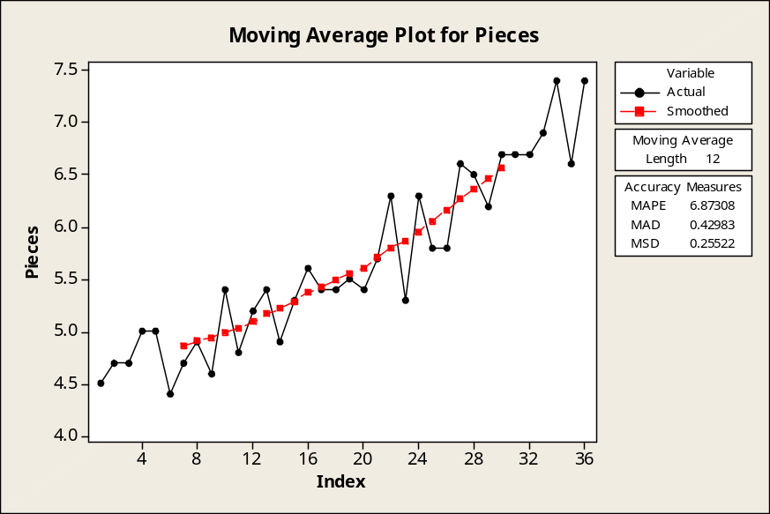

b. The centered moving average with N = 12 is much smoother because it is based on more months,
and also because the data may tend to be seasonal with a peak-to-peak period of 12 months.

18.15 p/a/m
a. The overall trend is upward.
b. The time series and the two centered moving averages are shown below.
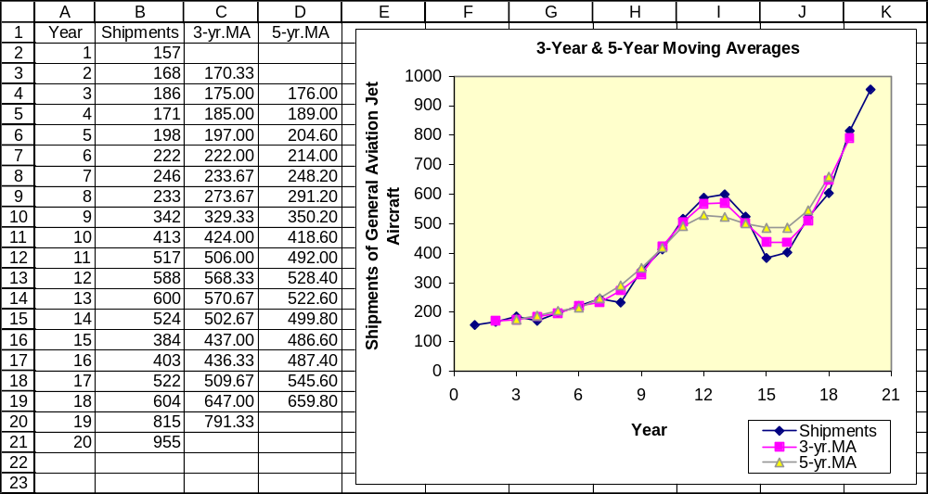

18.16 p/a/m Using Minitab and smoothing constant α = 0.4. For the smoothed values, refer to the "Smooth" column of this partial printout.

Single Exponential Smoothing for DegDays

Smoothing Constant Alpha 0.4

Time DegDays Smooth Predict Error
1 859 859.000 859.000 0.000
2 676 785.800 859.000 -183.000
3 648 730.680 785.800 -137.800
4 305 560.408 730.680 -425.680
5 186 410.645 560.408 -374.408
6 25 256.387 410.645 -385.645
7 3 155.032 256.387 -253.387
8 6 95.419 155.032 -149.032
9 39 72.852 95.419 -56.419
10 236 138.111 72.852 163.148
11 466 269.267 138.111 327.889
12 866 507.960 269.267 596.733
13 687 579.576 507.960 179.040
14 731 640.146 579.576 151.424
15 600 624.087 640.146 -40.146
16 264 480.052 624.087 -360.087
17 137 342.831 480.052 -343.052
18 23 214.899 342.831 -319.831
19 2 129.739 214.899 -212.899
20 9 81.444 129.739 -120.739
21 82 81.666 81.444 0.556
22 304 170.600 81.666 222.334
23 467 289.160 170.600 296.400
24 690 449.496 289.160 400.840
25 841 606.098 449.496 391.504
26 853 704.859 606.098 246.902
27 502 623.715 704.859 -202.859
28 372 523.029 623.715 -251.715
29 111 358.217 523.029 -412.029
30 24 224.530 358.217 -334.217
31 5 136.718 224.530 -219.530
32 7 84.831 136.718 -129.718
33 44 68.499 84.831 -40.831
34 175 111.099 68.499 106.501
35 521 275.059 111.099 409.901
36 800 485.036 275.059 524.941
37 892 647.821 485.036 406.964
38 741 685.093 647.821 93.179
39 617 657.856 685.093 -68.093
40 319 522.313 657.856 -338.856
41 183 386.588 522.313 -339.313
42 26 242.353 386.588 -360.588
43 5 147.412 242.353 -237.353
44 13 93.647 147.412 -134.412
45 52 76.988 93.647 -41.647
46 281 158.593 76.988 204.012
47 534 308.756 158.593 375.407
48 831 517.653 308.756 522.244

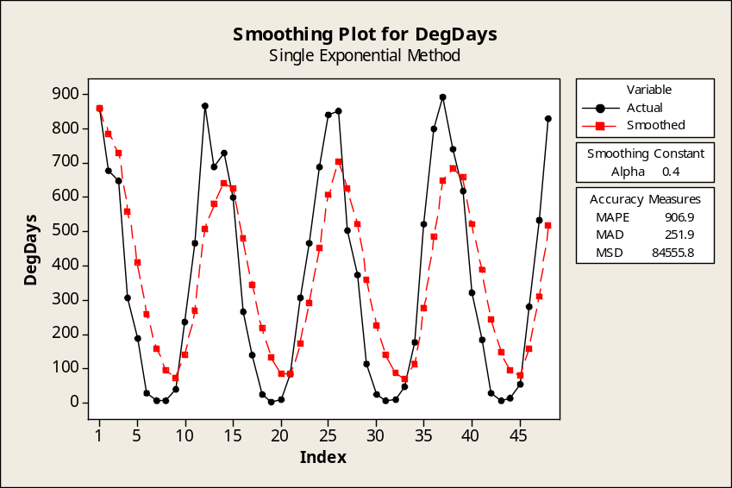

Using Minitab and smoothing constant α = 0.7. For the smoothed values, refer to the "Smooth" column of this partial printout.

Single Exponential Smoothing for DegDays

Smoothing Constant Alpha 0.7

Time DegDays Smooth Predict Error
1 859 859.000 859.000 0.000
2 676 730.900 859.000 -183.000
3 648 672.870 730.900 -82.900
4 305 415.361 672.870 -367.870
5 186 254.808 415.361 -229.361
6 25 93.942 254.808 -229.808
7 3 30.283 93.942 -90.942
8 6 13.285 30.283 -24.283
9 39 31.285 13.285 25.715
10 236 174.586 31.285 204.715
11 466 378.576 174.586 291.414
12 866 719.773 378.576 487.424
13 687 696.832 719.773 -32.773
14 731 720.750 696.832 34.168
15 600 636.225 720.750 -120.750
16 264 375.667 636.225 -372.225
17 137 208.600 375.667 -238.667
18 23 78.680 208.600 -185.600
19 2 25.004 78.680 -76.680
20 9 13.801 25.004 -16.004
21 82 61.540 13.801 68.199
22 304 231.262 61.540 242.460
23 467 396.279 231.262 235.738
24 690 601.884 396.279 293.721
25 841 769.265 601.884 239.116
26 853 827.880 769.265 83.735
27 502 599.764 827.880 -325.880
28 372 440.329 599.764 -227.764
29 111 209.799 440.329 -329.329
30 24 79.740 209.799 -185.799
31 5 27.422 79.740 -74.740
32 7 13.127 27.422 -20.422
33 44 34.738 13.127 30.873
34 175 132.921 34.738 140.262
35 521 404.576 132.921 388.079
36 800 681.373 404.576 395.424
37 892 828.812 681.373 210.627
38 741 767.344 828.812 -87.812
39 617 662.103 767.344 -150.344
40 319 421.931 662.103 -343.103
41 183 254.679 421.931 -238.931
42 26 94.604 254.679 -228.679
43 5 31.881 94.604 -89.604
44 13 18.664 31.881 -18.881
45 52 41.999 18.664 33.336
46 281 209.300 41.999 239.001
47 534 436.590 209.300 324.700
48 831 712.677 436.590 394.410

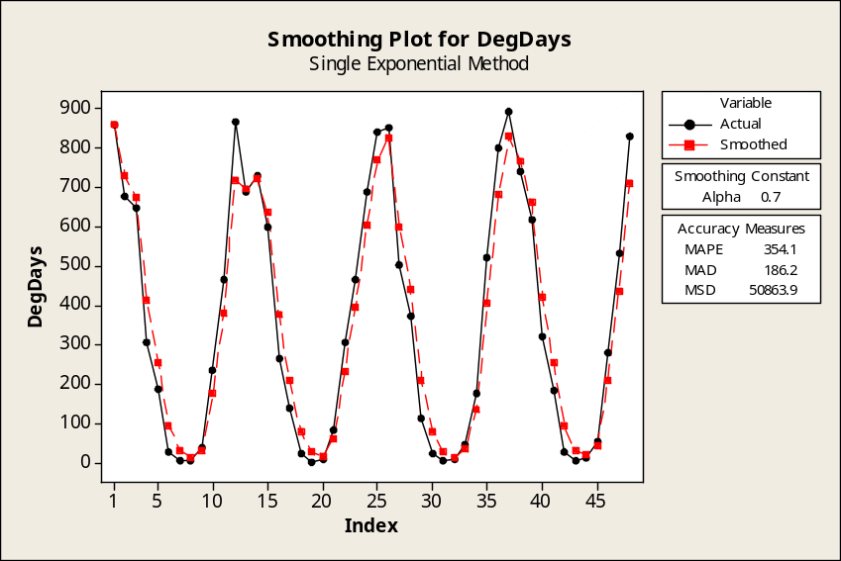

The smaller constant provides a smoother curve since it is weighted more heavily towards the previous smoothed value. The larger constant "catches up" with changes in direction in the original data series quicker because it gives more weight to the actual data series.

18.17 p/a/m Using Minitab and smoothing constant α = 0.4. For the smoothed values, refer to the "Smooth" column of this partial printout.

Single Exponential Smoothing for Pieces

Smoothing Constant Alpha 0.4

Time Pieces Smooth Predict Error
1 4.5 4.50000 4.50000 0.000000
2 4.7 4.58000 4.50000 0.200000
3 4.7 4.62800 4.58000 0.120000
4 5.0 4.77680 4.62800 0.372000
5 5.0 4.86608 4.77680 0.223200
6 4.4 4.67965 4.86608 -0.466080
7 4.7 4.68779 4.67965 0.020352
8 4.9 4.77267 4.68779 0.212211
9 4.6 4.70360 4.77267 -0.172673
10 5.4 4.98216 4.70360 0.696396
11 4.8 4.90930 4.98216 -0.182162
12 5.2 5.02558 4.90930 0.290703
13 5.4 5.17535 5.02558 0.374422
14 4.9 5.06521 5.17535 -0.275347
15 5.3 5.15912 5.06521 0.234792
16 5.6 5.33547 5.15912 0.440875
17 5.4 5.36128 5.33547 0.064525
18 5.4 5.37677 5.36128 0.038715
19 5.5 5.42606 5.37677 0.123229
20 5.4 5.41564 5.42606 -0.026063
21 5.7 5.52938 5.41564 0.284362
22 6.3 5.83763 5.52938 0.770617
23 5.3 5.62258 5.83763 -0.537630
24 6.3 5.89355 5.62258 0.677422
25 5.8 5.85613 5.89355 -0.093547
26 5.8 5.83368 5.85613 -0.056128
27 6.6 6.14021 5.83368 0.766323
28 6.5 6.28412 6.14021 0.359794
29 6.2 6.25047 6.28412 -0.084124
30 6.7 6.43028 6.25047 0.449526
31 6.7 6.53817 6.43028 0.269715
32 6.7 6.60290 6.53817 0.161829
33 6.9 6.72174 6.60290 0.297098
34 7.4 6.99304 6.72174 0.678259
35 6.6 6.83583 6.99304 -0.393045
36 7.4 7.06150 6.83583 0.564173

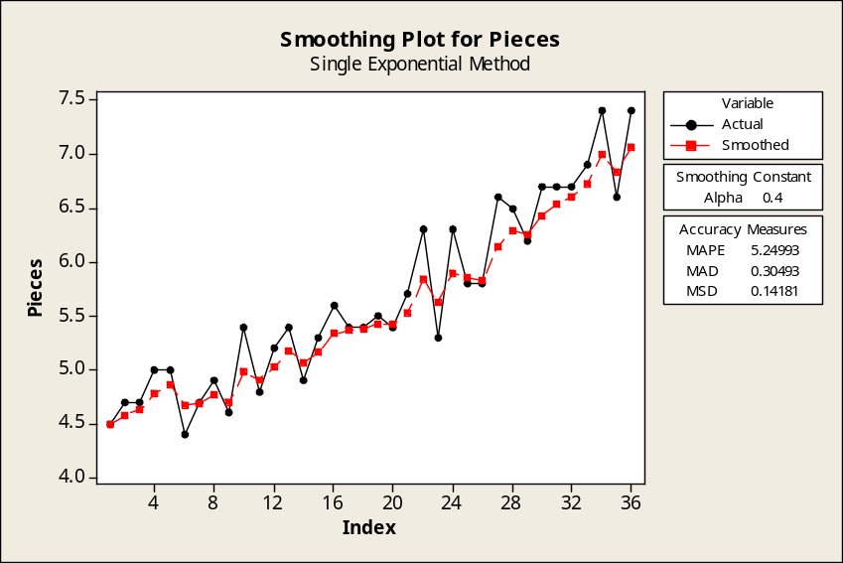

Using Minitab and smoothing constant α = 0.7. For the smoothed values, refer to the "Smooth" column of this partial printout.

Single Exponential Smoothing for Pieces

Smoothing Constant Alpha 0.7

Time Pieces Smooth Predict Error
1 4.5 4.50000 4.50000 0.000000
2 4.7 4.64000 4.50000 0.200000
3 4.7 4.68200 4.64000 0.060000
4 5.0 4.90460 4.68200 0.318000
5 5.0 4.97138 4.90460 0.095400
6 4.4 4.57141 4.97138 -0.571380
7 4.7 4.66142 4.57141 0.128586
8 4.9 4.82843 4.66142 0.238576
9 4.6 4.66853 4.82843 -0.228427
10 5.4 5.18056 4.66853 0.731472
11 4.8 4.91417 5.18056 -0.380558
12 5.2 5.11425 4.91417 0.285832
13 5.4 5.31428 5.11425 0.285750
14 4.9 5.02428 5.31428 -0.414275
15 5.3 5.21728 5.02428 0.275717
16 5.6 5.48519 5.21728 0.382715
17 5.4 5.42556 5.48519 -0.085185
18 5.4 5.40767 5.42556 -0.025556
19 5.5 5.47230 5.40767 0.092333
20 5.4 5.42169 5.47230 -0.072300
21 5.7 5.61651 5.42169 0.278310
22 6.3 6.09495 5.61651 0.683493
23 5.3 5.53849 6.09495 -0.794952
24 6.3 6.07155 5.53849 0.761514
25 5.8 5.88146 6.07155 -0.271546
26 5.8 5.82444 5.88146 -0.081464
27 6.6 6.36733 5.82444 0.775561
28 6.5 6.46020 6.36733 0.132668
29 6.2 6.27806 6.46020 -0.260200
30 6.7 6.57342 6.27806 0.421940
31 6.7 6.66203 6.57342 0.126582
32 6.7 6.68861 6.66203 0.037975
33 6.9 6.83658 6.68861 0.211392
34 7.4 7.23097 6.83658 0.563418
35 6.6 6.78929 7.23097 -0.630975
36 7.4 7.21679 6.78929 0.610708

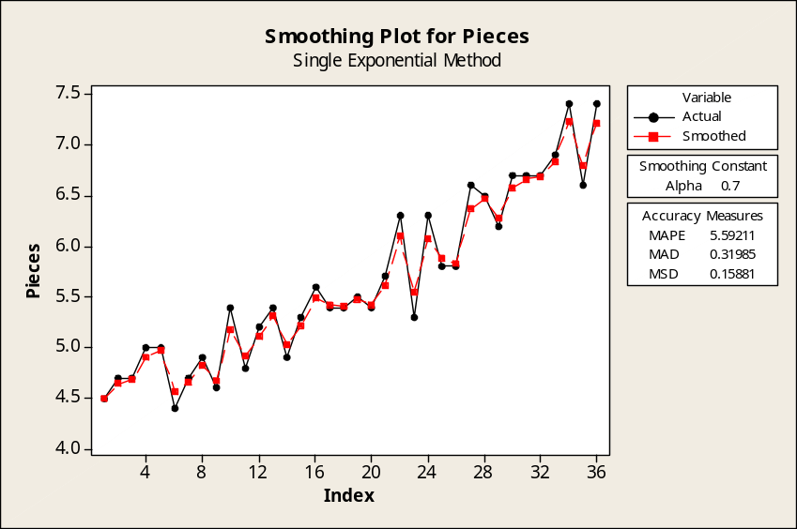

The smaller constant provides a smoother curve since it is weighted more heavily towards the previous smoothed value. The larger constant "catches up" with changes in direction in the original data series quicker because it gives more weight to the actual data series.

18.18 p/a/m Partial Minitab printout and plot for the centered moving average with N = 2.

Moving Average for Shipments

Moving Average Length 2

Time Shipments MA Predict Error
1 157 * * *
2 168 169.75 169.75 -1.75
3 186 177.75 177.75 8.25
4 171 181.50 181.50 -10.50
5 198 197.25 197.25 0.75
6 222 222.00 222.00 0.00
7 246 236.75 236.75 9.25
8 233 263.50 263.50 -30.50
9 342 332.50 332.50 9.50
10 413 421.25 421.25 -8.25
11 517 508.75 508.75 8.25
12 588 573.25 573.25 14.75
13 600 578.00 578.00 22.00
14 524 508.00 508.00 16.00
15 384 423.75 423.75 -39.75
16 403 428.00 428.00 -25.00
17 522 512.75 512.75 9.25
18 604 636.25 636.25 -32.25
19 815 797.25 797.25 17.75
20 955 * 797.25 157.75

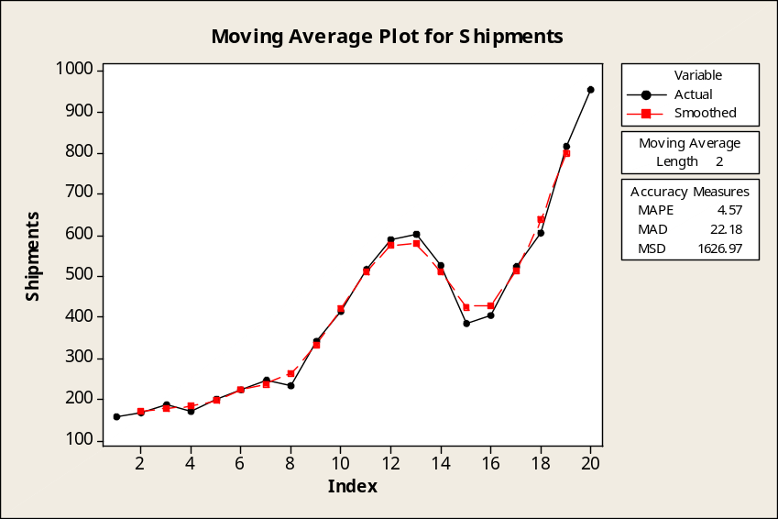

Partial Minitab printout and plot for the centered moving average with N = 4.

Moving Average for Shipments

Moving Average Length 4

Time Shipments MA Predict Error
1 157 * * *
2 168 * * *
3 186 175.625 * *
4 171 187.500 175.625 -4.625
5 198 201.750 187.500 10.500
6 222 217.000 201.750 20.250
7 246 242.750 217.000 29.000
8 233 284.625 242.750 -9.750
9 342 342.375 284.625 57.375
10 413 420.625 342.375 70.625
11 517 497.250 420.625 96.375
12 588 543.375 497.250 90.750
13 600 540.625 543.375 56.625
14 524 500.875 540.625 -16.625
15 384 468.000 500.875 -116.875
16 403 468.250 468.000 -65.000
17 522 532.125 468.250 53.750
18 604 655.000 532.125 71.875
19 815 * 655.000 160.000
20 955 * 655.000 300.000

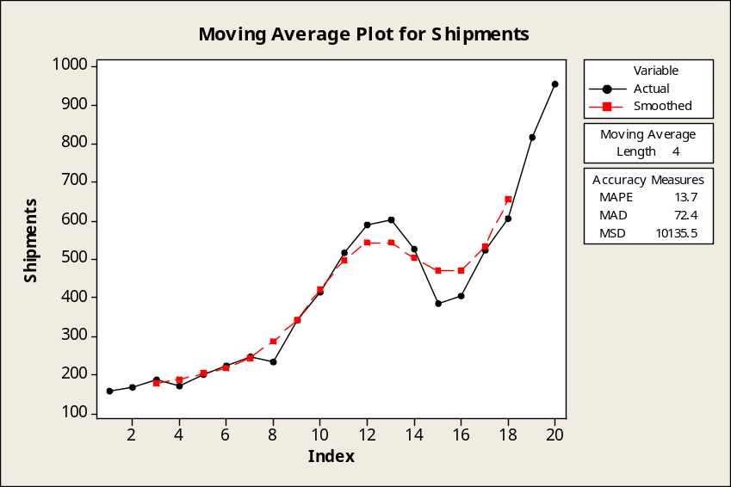

18.19 p/a/m
a. Partial printout and plot using Minitab with smoothing constant α = 0.6.

Single Exponential Smoothing for Shipments

Smoothing Constant Alpha 0.6

Time Shipments Smooth Predict Error
1 157 157.000 157.000 0.000
2 168 163.600 157.000 11.000
3 186 177.040 163.600 22.400
4 171 173.416 177.040 -6.040
5 198 188.166 173.416 24.584
6 222 208.467 188.166 33.834
7 246 230.987 208.467 37.533
8 233 232.195 230.987 2.013
9 342 298.078 232.195 109.805
10 413 367.031 298.078 114.922
11 517 457.012 367.031 149.969
12 588 535.605 457.012 130.988
13 600 574.242 535.605 64.395
14 524 544.097 574.242 -50.242
15 384 448.039 544.097 -160.097
16 403 421.015 448.039 -45.039
17 522 481.606 421.015 100.985
18 604 555.042 481.606 122.394
19 815 711.017 555.042 259.958
20 955 857.407 711.017 243.983

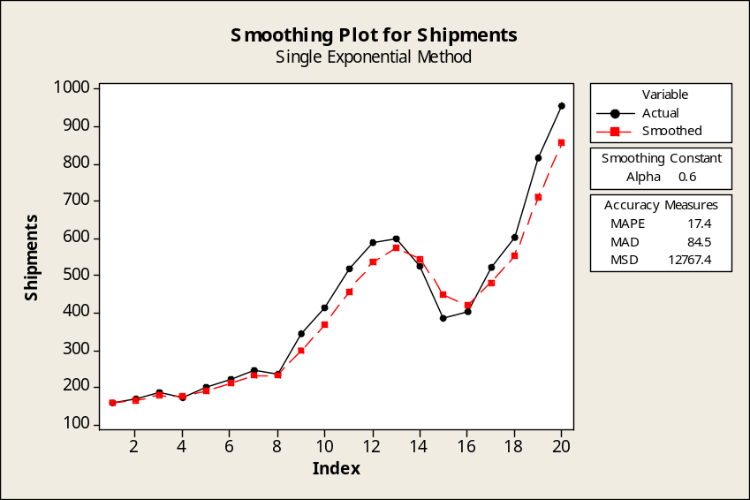

b. An exponentially-smoothed curve with α = 0.0 simply results in a horizontal line that provides no useful information. An exponentially-smoothed curve with α = 1.0 will exactly match the original time series; such a smoothing constant does not "smooth" the time series, it merely copies it.

18.20 c/a/e The statistician will multiply each seasonal index by the adjustment factor, 1200/1180.

18.21 p/a/m If the bookings were evenly distributed throughout the year, each quarter would have 25%
of the bookings. However, the second quarter is 120% as strong as the “average” quarter, so it will have 1.20 * 25.0 = 30.0% of the year’s bookings.

18.22 p/a/m We will use Excel worksheet template tmquarts. The procedure is described in the template. Part a of the exercise is represented by columns D, E, and F; part b by columns G and H (the seasonal indexes for the quarters are shown in cells H6:H9); and part c by column I. To get the chart shown here,
it was necessary to format the axes for minimum and maximum values corresponding to the data. 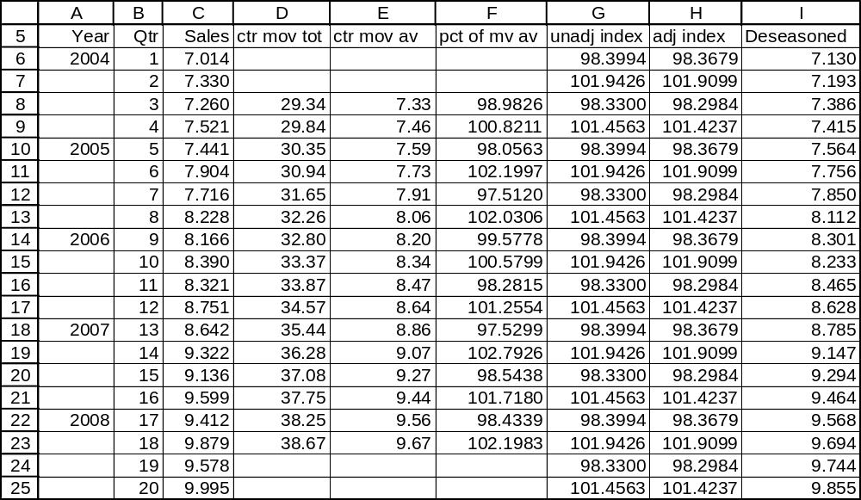

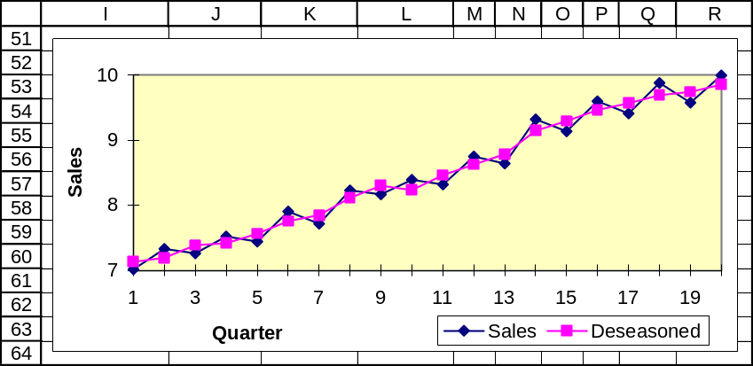

18.23 p/a/m For this seasonal index problem involving quarterly data, we will use Excel worksheet template tmquarts. The steps for its use are described within the worksheet template. Part a of the exercise is represented by columns D, E, and F; part b by columns G and H (the seasonal indexes for the quarters are shown in cells H6:H9); and part c by column I. To get the chart shown here, it was necessary to format the axes for minimum and maximum values corresponding to the data.
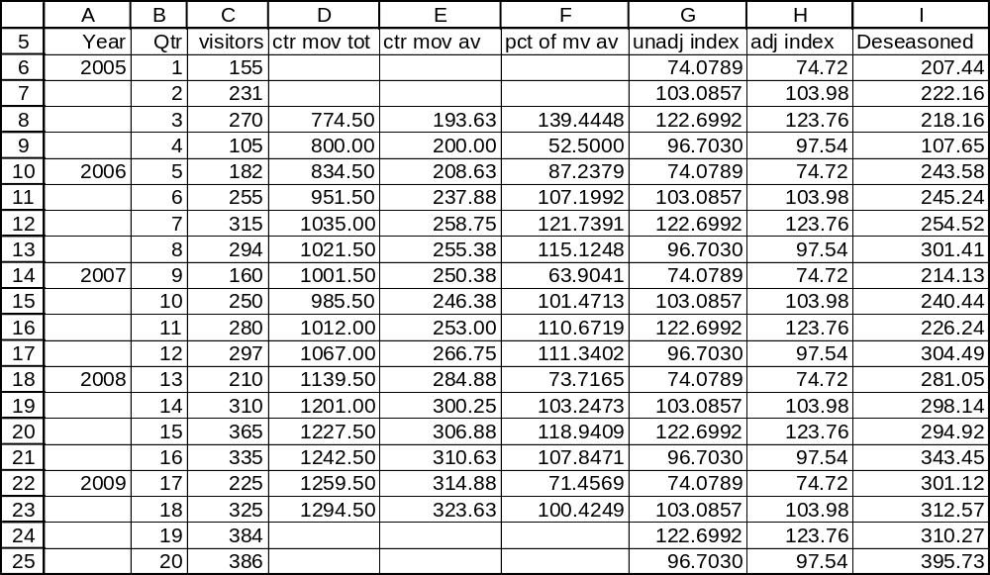

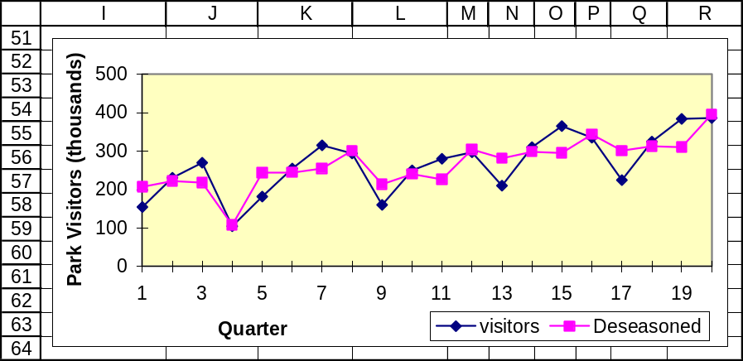

18.24 p/a/m We will use Excel worksheet template tmmonths. The steps for its use are described in the worksheet template. The seasonal indexes for the months are in cells H6:H17. To get the chart shown here, it was necessary to format the axes for minimum and maximum values corresponding to the data.
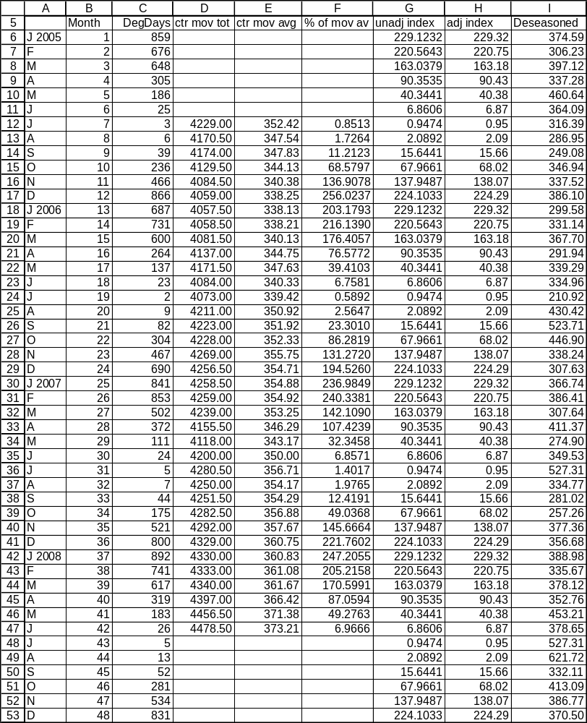

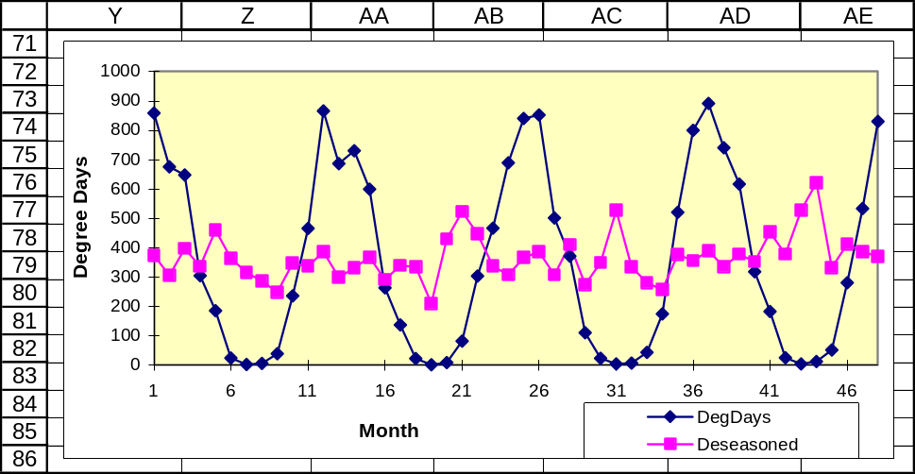

18.25 p/a/m For this seasonal index problem involving monthly data, we will use Excel worksheet template tmmonths. The steps for its use are described in the worksheet template. The seasonal indexes for the months are in cells H6:H17.To get the chart shown here, it was necessary to format the axes for minimum and maximum values corresponding to the data.
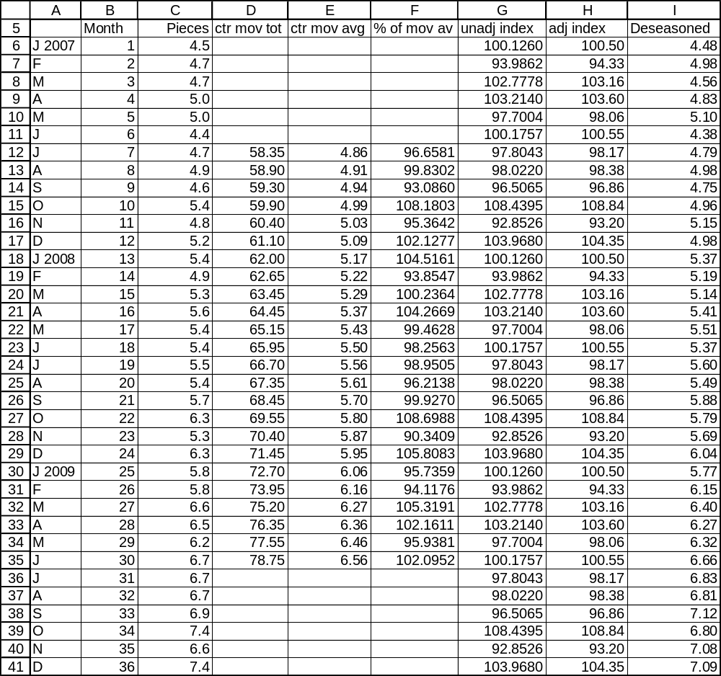

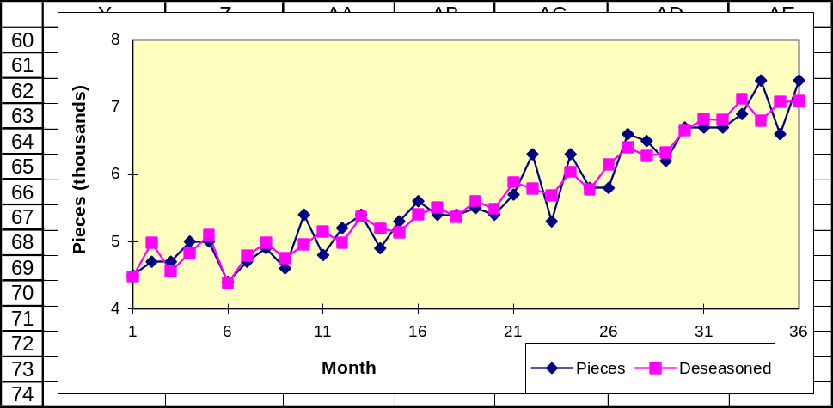

18.26 p/a/m
a. Using the seasonal indexes, deseasonalizing the data for 2009.
J | 7.2/(110/100) | = 6.55
F | 5.9/(105/100) | = 5.62
M | 5.5/( 90/100) | = 6.11
A | 3.2/( 60/100) | = 5.33
M | 4.0/( 70/100) | = 5.71
J | 4.1/( 75/100) | = 5.47
J | 5.3/( 85/100) | = 6.24
A | 5.4/( 95/100) | = 5.68
S | 5.7/(100/100) | = 5.70
O | 6.1/(105/100) | = 5.81
N | 7.9/(140/100) | = 5.64
D | 8.2/(165/100) | = 4.97

b. The president of the firm needs to examine the deseasonalized data, which have been adjusted to account for the seasonal fluctuations. Actually, the adjusted data reveal a downward trend over the last quarter.

18.27 c/a/e For 2013, x = 15, so the forecasted sales for 2013 are 120 + 4.8(15) = $192.0 thousand.
For 2015, x = 17, so the forecasted sales for 2015 are 120 + 4.8(17) = $201.6 thousand.

18.28 p/a/m For 2013, x = 9, so the forecasted number of repair orders is = 90 + 0.9(9) + 3(9)² = 341.1.
For 2015, x = 11, so the forecasted number of repair orders is = 90 + 0.9(11) + 3(11)² = 462.9.

18.29 p/a/m For 2013, x = 9, so the forecasted number of rentals is = 450 + 20(9) + 7.2(9)² = 1213.2. For 2015, x = 11, so the forecasted number of rentals is = 450 + 20(11) + 7.2(11)² = 1541.2.

18.30 d/p/m When exponential smoothing is used to smooth a time series, the formula for the current period includes the exponentially-smoothed value for the previous period and the actual value for the current period. However, when exponential smoothing is used to forecast, the formula for the next period includes the forecasted value for the current period and the actual data for the current period. Thus, in smoothing, the smoothed data is the combination of the smoothed data for previous periods and actual data for current periods. In forecasting, the forecast for the next period is the combination of the forecast and the actual data for the current period.

18.31 p/a/m Using Minitab, the calculation summary is shown in the partial printout below. Refer to the "Predict" and “Forecast” columns. The years are coded so that 2000 is period 1.

Single Exponential Smoothing for Deficit

Data Deficit
Length 8

Smoothing Constant Alpha 0.7

Time Deficit Smooth Predict Error
1 51.9 51.9000 51.9000 0.0000
2 52.8 52.5300 51.9000 0.9000
3 48.2 49.4990 52.5300 -4.3300
4 51.7 51.0397 49.4990 2.2010
5 66.5 61.8619 51.0397 15.4603
6 78.5 73.5086 61.8619 16.6381
7 71.8 72.3126 73.5086 -1.7086
8 68.2 69.4338 72.3126 -4.1126

Forecasts
Period Forecast Lower Upper
9 69.4338 55.5454 83.3221

Calculations are: (next period forecast) = 0.7(this period actual) + 0.3(this period forecast).
Thus, the forecast for period 9 (2008) would be 0.7(actual in period 8) + 0.3(forecast for period 8),
or 0.7(68.2) + 0.3(72.3126) = $69.43 billion.

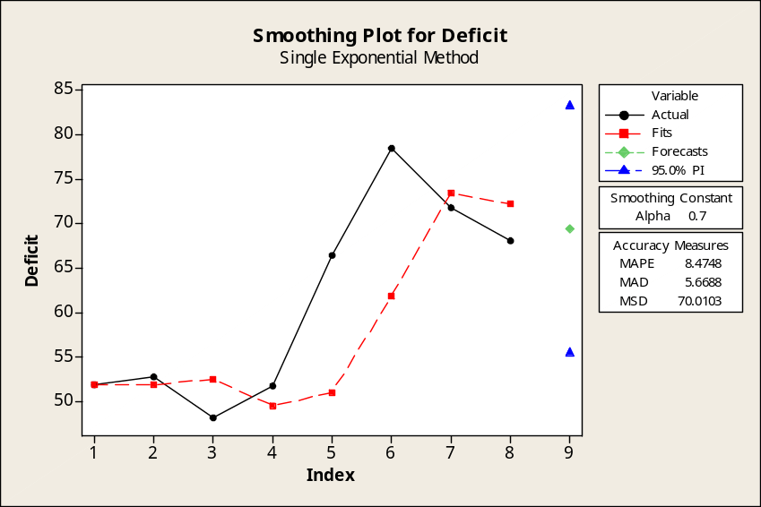

In using Excel, we would specify 0.3 as the "damping factor" (i.e., 1 minus our smoothing constant,
α = 0.7). Excel places the forecast for a period next to the preceding period, so we must shift the forecasts downward by one period. Also, we need to manually fill in the initial forecast for 2000 (51.900 in cell C2), click on the lower right corner of cell C9, then drag and autofill to cell C10 to obtain the
forecast for 2008. The result is shown below.
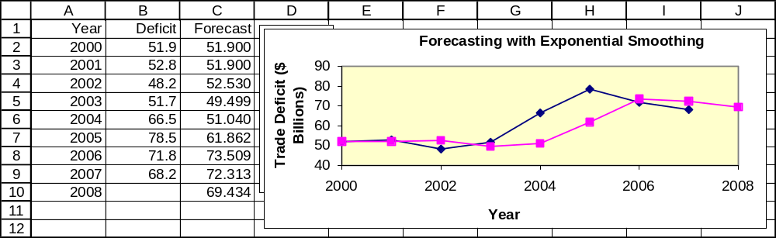

18.32 p/a/m In the partial Minitab printout below, refer to the “Predict” and “Forecast” columns.

Single Exponential Smoothing for Subs

Data Subs
Length 12

Smoothing Constant Alpha 0.5

Time Subs Smooth Predict Error
1 44.0 44.000 44.000 0.0000
2 55.3 49.650 44.000 11.3000
3 69.2 59.425 49.650 19.5500
4 86.0 72.713 59.425 26.5750
5 109.5 91.106 72.713 36.7875
6 128.4 109.753 91.106 37.2938
7 140.8 125.277 109.753 31.0469
8 158.7 141.988 125.277 33.4234
9 182.1 162.044 141.988 40.1117
10 207.9 184.972 162.044 45.8559
11 233.0 208.986 184.972 48.0279
12 255.4 232.193 208.986 46.4140

Forecasts
Period Forecast Lower Upper
13 232.193 155.349 309.037

The forecast for period 13 (2008) will be 0.5(actual in period 12) + 0.5(forecast for period 12),
or 0.5(255.4) + 0.5(208.986) = 232.19 million subscribers.

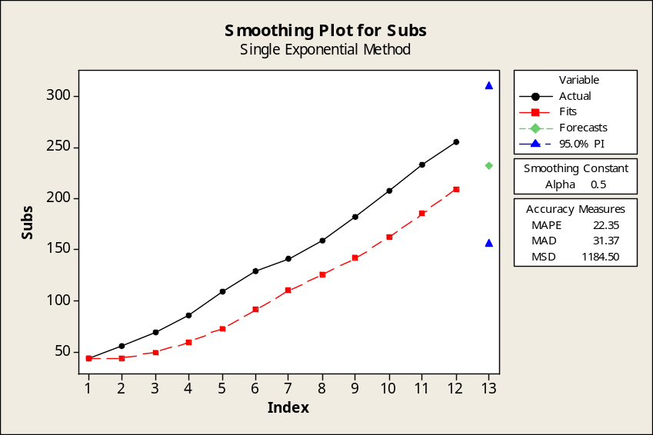
With Excel, we specify 0.5 as the "damping factor" (i.e., 1 - smoothing constant, α = 0.5). Excel places each forecast next to the preceding period, so we must shift the forecasts down by one period.
We manually insert the initial forecast (44.000 in cell C2), click on the lower right corner of cell C13,
then autofill to cell C14 to get the forecast for 2008. The result is shown below.
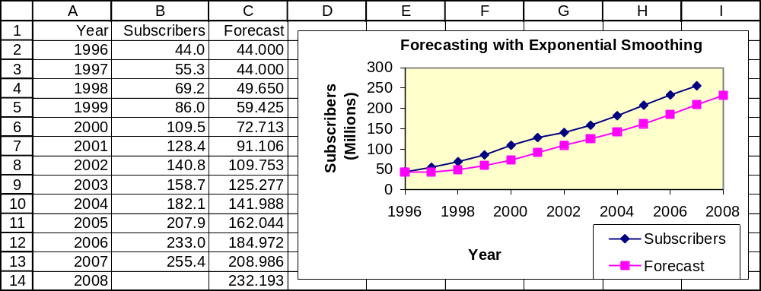

18.33 p/a/m In the partial Minitab printout below, refer to the “Predict” and “Forecast” columns.

Single Exponential Smoothing for NatGas

Data NatGas
Length 16

Smoothing Constant Alpha 0.6

Time NatGas Smooth Predict Error
1 29.6 29.6000 29.6000 0.00000
2 30.6 30.2000 29.6000 1.00000
3 30.8 30.5600 30.2000 0.60000
4 33.3 32.2040 30.5600 2.74000
5 33.0 32.6816 32.2040 0.79600
6 33.0 32.8726 32.6816 0.31840
7 32.8 32.8291 32.8726 -0.07264
8 36.0 34.7316 32.8291 3.17094
9 37.7 36.5126 34.7316 2.96838
10 37.3 36.9851 36.5126 0.78735
11 38.2 37.7140 36.9851 1.21494
12 38.6 38.2456 37.7140 0.88598
13 38.8 38.5782 38.2456 0.55439
14 39.6 39.1913 38.5782 1.02176
15 38.6 38.8365 39.1913 -0.59130
16 40.2 39.6546 38.8365 1.36348

Forecasts
Period Forecast Lower Upper
17 39.6546 36.8853 42.4239

The forecast for period 17 (2008) will be 0.6(actual in period 16) + 0.4(forecast for period 16),
or 0.6(40.2) + 0.4(38.8365) = 39.655 quadrillion Btu.

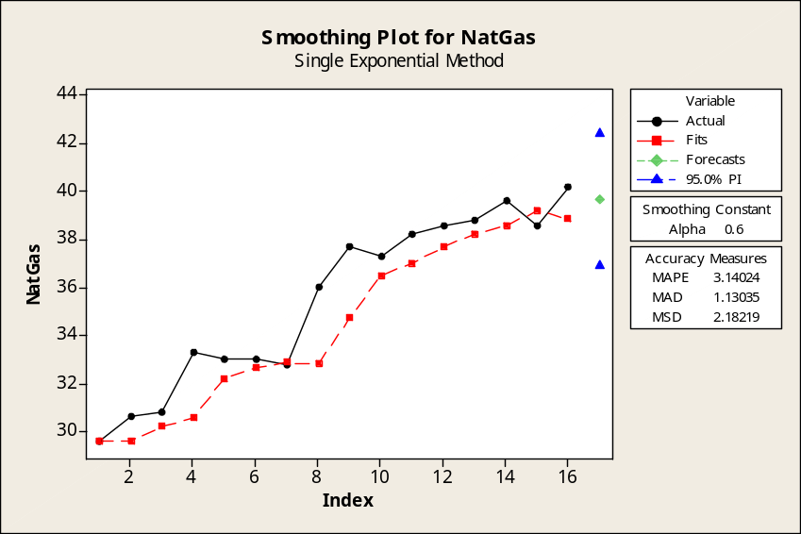

With Excel, we specify 0.4 as the "damping factor" (i.e., 1 - smoothing constant, α = 0.6). Excel places each forecast next to the preceding period, so we must shift the forecasts down by one period. Manually insert the initial forecast (29.600 in cell C2), click on the lower right corner of cell C17, then autofill to cell C18 to get the forecast for 2008. The result is shown below.

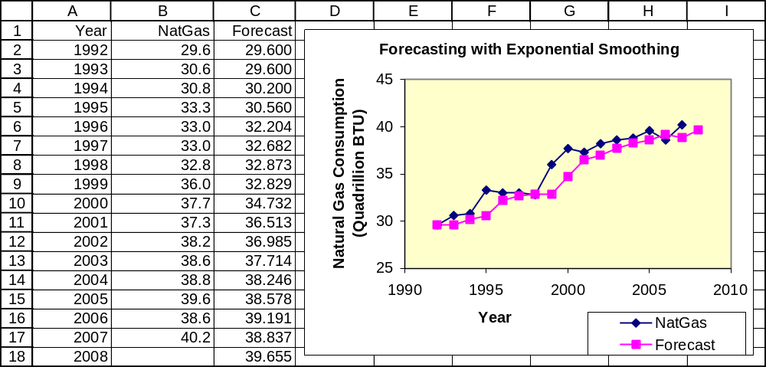

18.34 d/p/d Exponential smoothing will tend to produce forecasts that are under the sales that are actually realized during a period of consistently increasing sales. This is due to the fact that exponentially smoothed forecasts are the weighted average of the actual and forecasted data from the preceding time period. Thus, in a period of rising sales, the forecast is the weighted average of two numbers that are both smaller than what future sales values will likely be.

18.35 p/a/m The forecast for the second quarter is (560,000/4)(135/100) = 189,000 gallons.

18.36 p/a/m The forecasts for quarterly electricity consumption during 2014 are:
I | (850,000/ 4)*(115/100) | = 244,375
II | (850,000/ 4)*( 92/100) | = 195,500
III | (850,000/ 4)*( 81/100) | = 172,125
IV | (850,000/ 4)*(112/100) | = 238,000

18.37 d/p/e MAD considers the mean absolute error from the actual data; the direction of the error is not considered. In calculating MAD, the absolute values of the deviations are used. MSE considers the mean squared error from the actual data. In calculating MSE, the squared deviations from the actual data are used. The MSE approach penalizes large errors more since the errors are squared.

18.38 p/a/m Using Excel, the relevant calculation results are shown below.
Linear trend equation.

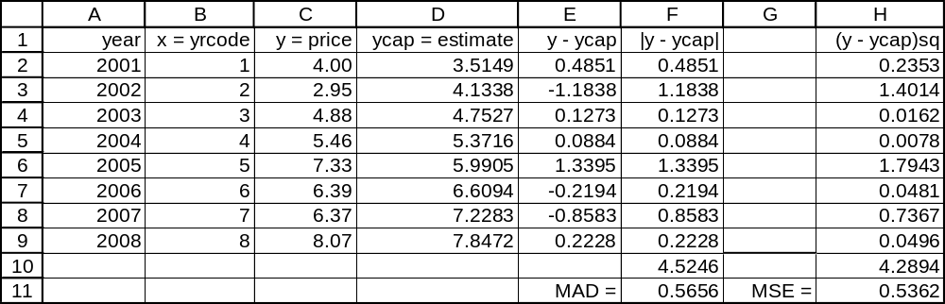

Quadratic trend equation.
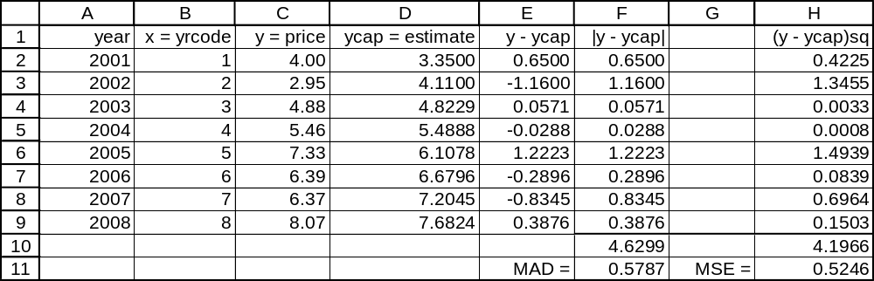

Using the MAD criterion, the linear trend equation is the better fit. Using the MSE criterion, the quadratic trend equation is the better fit. In solving this exercise, we could also use Minitab’s trend analysis capability – the the MAD and MSE (“MSD”) values are automatically provided, and they will be slightly more accurate (at the fourth decimal place) than the ones calculated here on the basis of the (rounded) equations given in the exercise. Nevertheless, Minitab verifies that MAD favors the linear trend equation and MSE favors the quadratic trend equation. It may seem surprising that MAD would favor the linear equation over the more-complex quadratic trend equation, but keep in mind that trend equations are based on a least-squares method that focuses on minimizing the sum of squared deviations rather than the sum of absolute deviations.

18.39 p/a/m Using Excel, the relevant calculation results are shown below.
Linear trend equation.
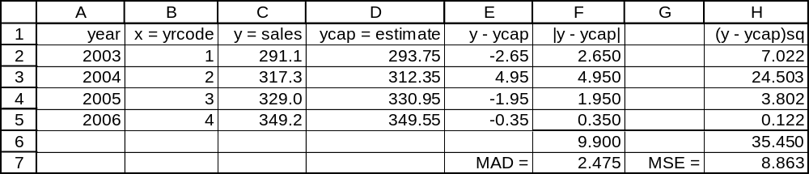

Quadratic trend equation.
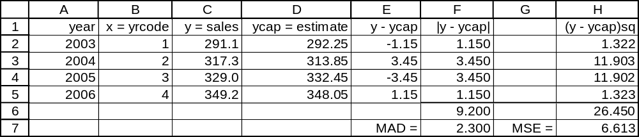

The quadratic equation is the better fit. This is true regardless of whether MAD or MSE is considered.
In solving this exercise, we could also use Minitab’s trend analysis capability – the MAD and MSE values are automatically provided, and they will be slightly more accurate than the ones calculated here on the basis of the (rounded) equations given in the exercise.

18.40 p/c/m Referring to the Minitab plots shown in the solution to exercise 18.7, the MAD and MSE values are as shown below. Note that Minitab shows MSE as "MSD".
Linear trend equation: MAD = 5.3154 MSE = 41.1571
Quadratic trend equation: MAD = 2.34299 MSE = 7.75938
The MAD and MSE are also displayed in the standard Minitab Trend Analysis printout for a trend equation. These were not included in the partial printouts shown in the solution to exercise 18.7.
On the basis of either MAD or MSE, the quadratic trend equation is the better fit. These results could also be obtained by using the approach taken in exercises 18.38 and 18.39.

18.41 p/c/m Referring to the Minitab plots shown in the solution to exercise 18.8, the MAD and MSE values are as shown below. Note that Minitab shows MSE as "MSD".
Linear trend equation: MAD = 7.0750 MSE = 76.0895
Quadratic trend equation: MAD = 4.2774 MSE = 20.8799
The MAD and MSE are also displayed in the standard Minitab Trend Analysis printout for a trend equation. These were not included in the partial printouts shown in the solution to exercise 18.8.
On the basis of either MAD or MSE, the quadratic trend equation is the better fit. These results could also be obtained by using the approach taken in exercises 18.38 and 18.39.

18.42 d/p/d When autocorrelation of the residuals is present, the interval estimations will tend to be too narrow, and the respective independent variables will be exaggerated in their significance.

18.43 d/p/d The Durbin-Watson test is used to detect the presence of autocorrelation between adjacent residuals. If the test detects the presence of autocorrelation, there is the possibility in the given model that important variables may have been omitted. The inclusion of these variables can reduce the presence of autocorrelation and enhance the quality of confidence and prediction intervals.

18.44 p/a/m The null and alternative hypotheses are H₀: ρ ≤ 0 and H₁: ρ > 0. Using Excel and the information provided, the relevant calculation results are shown below.
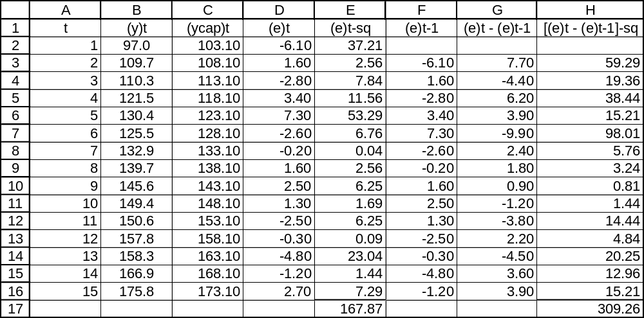

The Durbin-Watson statistic is d = 309.26/167.87 = 1.84.
In the Durbin-Watson table for α = 0.05 for a directional test, the listed values for n = 15 observations and k = 1 independent variable are d_{L} = 1.08 and d_{U} = 1.36. We are testing for positive autocorrelation, so the listed value of interest is d_{L} = 1.08. Because d = 1.84 is not less than d_{L} = 1.08, there is no evidence of positive autocorrelation at this level of significance. (Refer to the “testing for positive autocorrelation” portion of Figure 18.5 in the text.) Minitab offers the Durbin-Watson statistic as an option in regression analysis, as shown below.

Regression Analysis: Yt versus t

The regression equation is Yt = 98.1 + 5.00 t

Predictor Coef SE Coef T P
Constant 98.062 1.953 50.22 0.000
t 5.0039 0.2147 23.30 0.000

S = 3.593 R-Sq = 97.7% R-Sq(adj) = 97.5%

Analysis of Variance
Source DF SS MS F P
Regression 1 7011.0 7011.0 542.95 0.000
Residual Error 13 167.9 12.9
Total 14 7178.9

Durbin-Watson statistic = 1.84

We can also use Data Analysis Plus to examine the residuals and compute the Durbin-Watson statistic.
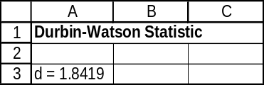
18.45 p/a/m The null and alternative hypotheses are H₀: ρ ≤ 0 and H₁: ρ > 0. Using Excel and the information provided, the relevant calculation results are shown below.
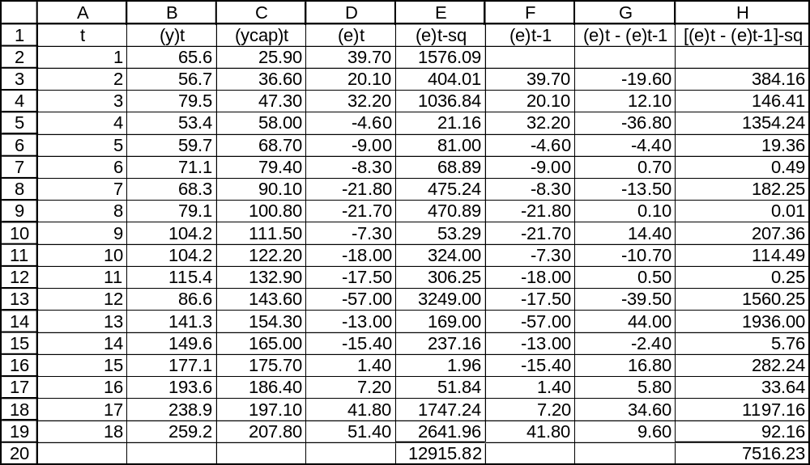

The Durbin-Watson statistic is d = 7516.23/12,915.82 = 0.58.
In the Durbin-Watson table for α = 0.05 for a directional test, the listed values for n = 18 observations and k = 1 independent variable are d_{L} = 1.16 and d_{U} = 1.39. We are testing for positive autocorrelation, so the listed value of interest is d_{L} = 1.16. Because d = 0.58 is less than d_{L} = 1.16, we conclude that positive autocorrelation exists and the linear model may not be appropriate for this series. (Refer to the “testing for positive autocorrelation” portion of Figure 18.5 in the text.) Minitab offers the Durbin-Watson statistic as an option in regression analysis, as shown below.

Regression Analysis: Yt versus t

The regression equation is Yt = 15.2 + 10.7 t

Predictor Coef SE Coef T P
Constant 15.20 13.97 1.09 0.293
t 10.701 1.291 8.29 0.000

S = 28.41 R-Sq = 81.1% R-Sq(adj) = 79.9%

Analysis of Variance
Source DF SS MS F P
Regression 1 55479 55479 68.73 0.000
Residual Error 16 12916 807
Total 17 68395

Durbin-Watson statistic = 0.58

We can also use Data Analysis Plus to examine the residuals and compute the Durbin-Watson statistic.
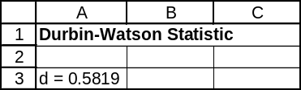

18.46 p/a/m Given n = 20, k = 3, and d = 0.91:
a. The null and alternative hypotheses are H₀: ρ = 0 and H₁: ρ ≠ 0.
From the table, with α = 0.02, d_{L} = 0.77 and d_{U} = 1.41.
Since d_{L} < d < d_{U} , do not reject H₀. Conclusion: The test is inconclusive.
b. The null and alternative hypotheses are H₀: ρ ≤ 0 and H₁: ρ > 0.
From the table, with α = 0.05, d_{L} = 1.00 and d_{U} = 1.68.
Since d < d_{L}, reject H₀. Conclusion: There is a positive autocorrelation.

18.47 p/a/m Given n = 16, k = 2, and d = 2.78:
a. The null and alternative hypotheses are H₀: ρ = 0 and H₁: ρ ≠ 0.
From the table, with α = 0.05, d_{L} = 0.86 and d_{U} = 1.40.
4 - d_{U} = 4 - 1.40 = 2.6 and 4 - d_{L} = 4 - 0.86 = 3.14.
Thus, d = 2.78 is greater than 4 - d_{U}, but d is less than 4 - d_{L}.
Conclusion: The test is inconclusive.
b. The null and alternative hypotheses are H₀: ρ ≥ 0 and H₁: ρ < 0.
From the table, with α = 0.01, d_{L} = 0.74 and d_{U} = 1.25.
4 - d_{U} = 4 - 1.25 = 2.75 and 4 - d_{L} = 4 - 0.74 = 3.26.
Thus, with d = 2.78, (4 - d_{U} ) < d < (4 - d_{L}). Conclusion: the test is inconclusive.

18.48 p/a/e Given 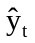 = 34.50 + 0.58y_{t-1} - 0.72y_{t-2}, with 260 thousand visitors this week and 245 thousand last week, this equation would predict 34.50 + 0.58(260) - 0.72(245) = 8.9 thousand visitors next week. This is an extreme decrease from the previous weeks’ totals, suggesting that this site’s sequence of weekly visitor totals may exhibit some rather bizarre patterns.

18.49 p/c/m The Minitab printout is shown below.

Regression Analysis: Yt versus Yt-1

The regression equation is Yt = - 1.5 + 1.12 Yt-1

17 cases used 1 cases contain missing values

Predictor Coef SE Coef T P
Constant -1.51 11.88 -0.13 0.901
Yt-1 1.11889 0.09859 11.35 0.000

S = 21.36 R-Sq = 89.6% R-Sq(adj) = 88.9%

Analysis of Variance
Source DF SS MS F P
Regression 1 58768 58768 128.79 0.000
Residual Error 15 6845 456
Total 16 65613

Predicted Values for New Observations
New Obs Fit SE Fit 95.0% CI 95.0% PI
1 288.51 15.74 ( 254.96, 322.05) ( 231.95, 345.06) X
X denotes a row with X values away from the center

Values of Predictors for New Observations
New Obs Yt-1
1 259

The first-order autoregressive forecasting equation is = -1.51 + 1.119y_{t-1}.
The shipment value in period 18 was 259.2, and Minitab shows a forecast value of 288.51 for period 19. This can also be calculated as -1.51 + 1.119(259.2) = 288.5. (Note: Minitab carries more decimal places for the constant and coefficients than are shown in the printout, so Minitab calculations like these will tend to be slightly more accurate than the ones we are able to make.)
18.50 p/c/m The Minitab printout is shown below.

Regression Analysis: Yt versus Yt-1, Yt-2

The regression equation is Yt = 13.3 + 1.52 Yt-1 - 0.557 Yt-2

16 cases used, 2 cases contain missing values

Predictor Coef SE Coef T P
Constant 13.264 5.316 2.50 0.027
Yt-1 1.5222 0.1963 7.75 0.000
Yt-2 -0.5574 0.1917 -2.91 0.012

S = 5.86360 R-Sq = 99.4% R-Sq(adj) = 99.4%

Analysis of Variance
Source DF SS MS F P
Regression 2 79639 39819 1158.15 0.000
Residual Error 13 447 34
Total 15 80086

Predicted Values for New Observations
New
Obs Fit SE Fit 95% CI 95% PI
1 307.54 2.61 (301.91, 313.18) (293.68, 321.41)

Values of Predictors for New Observations
New
Obs Yt-1 Yt-2
1 299 289

The second-order autoregressive forecasting equation is = 13.264 + 1.5222y_{t-1} - 0.5574y_{t-2}.
The data values for periods 18 and 17 were 299.0 million accounts and 288.6 million accounts, respectively, and Minitab shows a forecast of 307.54 million accounts for period 19 (2008).
This can also be calculated as 13.264 + 1.5222(299.0) - 0.5574(288.6) = 307.54 million accounts.

18.51 p/c/m The Minitab printout is shown below.

Regression Analysis: Yt versus Yt-1

The regression equation is Yt = 526 + 0.812 Yt-1

19 cases used 1 cases contain missing values

Predictor Coef SE Coef T P
Constant 525.6 171.8 3.06 0.007
Yt-1 0.81198 0.05127 15.84 0.000

S = 134.0 R-Sq = 93.7% R-Sq(adj) = 93.3%

Analysis of Variance
Source DF SS MS F P
Regression 1 4504124 4504124 250.78 0.000
Residual Error 17 305326 17960
Total 18 4809450

Predicted Values for New Observations
New Obs Fit SE Fit 95.0% CI 95.0% PI
1 2895.5 36.4 ( 2818.8, 2972.2) ( 2602.5, 3188.4)

Values of Predictors for New Observations
New Obs Yt-1
1 2919

The first-order autoregressive forecasting equation is = 525.6 + 0.812y_{t-1}.
The carrying cost in period 20 was $2918.6 thousand and Minitab shows a forecast value of $2895.5 thousand for period 21. This can also be calculated as 525.6 + 0.812(2918.6) = $2895.5 thousand.
In carrying out the regression, the residuals were stored into a separate column and the mean of their absolute values is MAD = $100.5 thousand.

18.52 p/c/m The Minitab printout is shown below.

Regression Analysis: Yt versus Yt-1, Yt-2

The regression equation is Yt = 456 + 0.609 Yt-1 + 0.221 Yt-2

18 cases used 2 cases contain missing values

Predictor Coef SE Coef T P
Constant 455.6 205.6 2.22 0.043
Yt-1 0.6089 0.2308 2.64 0.019
Yt-2 0.2209 0.1939 1.14 0.272

S = 127.5 R-Sq = 93.6% R-Sq(adj) = 92.7%

Analysis of Variance
Source DF SS MS F P
Regression 2 3541480 1770740 108.87 0.000
Residual Error 15 243975 16265
Total 17 3785455

Predicted Values for New Observations
New Obs Fit SE Fit 95.0% CI 95.0% PI
1 2881.7 35.4 ( 2806.2, 2957.2) ( 2599.6, 3163.8)

Values of Predictors for New Observations
New Obs Yt-1 Yt-2
1 2919 2938

The second-order autoregressive forecasting equation is = 455.6 + 0.6089y_{t-1} + 0.2209y_{t-2}.
The data values for periods 20 and 19 were $2918.6 thousand and $2938.1 thousand, respectively, and Minitab shows a forecast of $2881.7 thousand for period 21.
This can also be calculated as 455.6 + 0.6089(2918.6) + 0.2209(2938.1) = $2882 thousand. (Once again, note that Minitab carries more decimal places for the constant and coefficients than are shown in the printout, so Minitab calculations like these will tend to be slightly more accurate than the ones we are able to make.)
In carrying out the regression, the residuals were stored into a separate column and the mean of their absolute values is MAD = $99.1 thousand. Using the MAD criterion, the second-order autoregressive model is a slightly better fit than the first-order model in exercise 18.51.

18.53 d/p/e An index number is a percentage that expresses a measurement in a given period in terms of the corresponding measurement for a selected base period. The value of any index number for the base period is always 100.0.

18.54 d/p/m The Consumer Price Index (CPI) is an index which describes prices from one time period to another for a fixed "market basket" of goods and services.

18.55 p/a/d To determine which earner groups fared best and worst in terms of their percentage change in spending power during this period, we must compute ratios of both earnings and the CPI, then compare the ratios. Of course, one problem with these data is that we have only average hourly earnings; we do not know whether the number of hours worked per week increased, decreased, or remained fairly constant.
By 2007, the CP1 was 1.586 times its size in 1990. In 2007, the average hourly wage in manufacturing was 1.601 times as large as its 1990 value. Corresponding multiples for the construction and the leisure and hospitality industries were 1.561 and 1.729, respectively. To examine changes in spending power in each sector, we can look at the ratio of the change in wages to the change in the CPI:

For manufacturing, the ratio is (1.601/1.586)*100 = 100.95. Therefore, workers in this industry experienced a 0.95% increase in spending power between 1990 and 2007.
For construction, the ratio is (1.561/1.586)*100 = 98.42. So, workers in this industry experienced a 1.58% decline in spending power between 1990 and 2007.
For leisure and hospitality, the ratio is (1.729/1.586)*100 = 109.02. Therefore, workers in the leisure and hospitality industry experienced a 9.02% increase in spending power between 1990 and 2007.

The wage-earners who fared best were in the leisure and hospitality industry; those who fared worst were in the construction industry.

18.56 p/a/m In 2007, the executive's salary is 1.368 times its 2000 level. The Consumer Price Index grew to 1.204 times its 2000 level over this same period. Therefore, her real earnings changed by (1.368/1.204)*100 = 113.62; this represents a 13.62% increase in real earnings.

18.57 p/a/m To get the executive's 2000 salary into 2007 equivalent dollars, we must take the ratio of the 2007 CPI to the 2000 CPI and multiply this by her 2000 salary. Therefore, the 2000 salary in its 2007 equivalent dollars is: (207.3/172.2)*95,000 = $114,364.

18.58 p/a/e We can convert the index numbers (present base = 1982) by dividing each index number by the index number for 2002, then multiplying the quotient by 100. For example, the 2006 value is calculated as (207.2/181.9)*100 = 113.91. The calculation results for all the years are shown below.
 | Index Number, | Index Number,
Year | 1982 Base | 2002 Base
2002 | 181.9 | 100.00
2003 | 183.4 | 100.82
2004 | 188.3 | 103.52
2005 | 197.6 | 108.63
2006 | 207.2 | 113.91
2007 | 220.8 | 121.39

CHAPTER EXERCISES

18.59 p/c/m With x = 1 for 2001, the linear trend equation is Army = 476.29 + 5.4643x.
For 2015, x = 15, and the forecast for 2015 can be calculated as 476.29 + 5.4643(15) = 558.25 thousand.
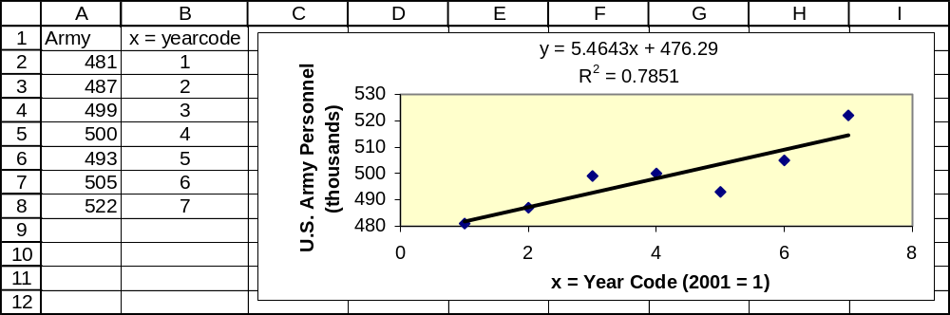

18.60 p/a/m The Minitab printout is shown below. Refer to the "Predict" column of the printout.

Single Exponential Smoothing for Army

Data Army
Length 7

Smoothing Constant Alpha 0.7

Time Army Smooth Predict Error
1 481 481.000 481.000 0.0000
2 487 485.200 481.000 6.0000
3 499 494.860 485.200 13.8000
4 500 498.458 494.860 5.1400
5 493 494.637 498.458 -5.4580
6 505 501.891 494.637 10.3626
7 522 515.967 501.891 20.1088

Forecasts
Period Forecast Lower Upper
8 515.967 494.663 537.271

Calculations are: (next period forecast) = 0.7(this period actual) + 0.3(this period forecast).
Thus, the forecast for period 8 (2008) would be 0.7(actual in period 7) + 0.3(forecast for period 7),
or 0.7(522.0) + 0.3(501.891) = 515.97 thousand army personnel. The Minitab plot is shown below.
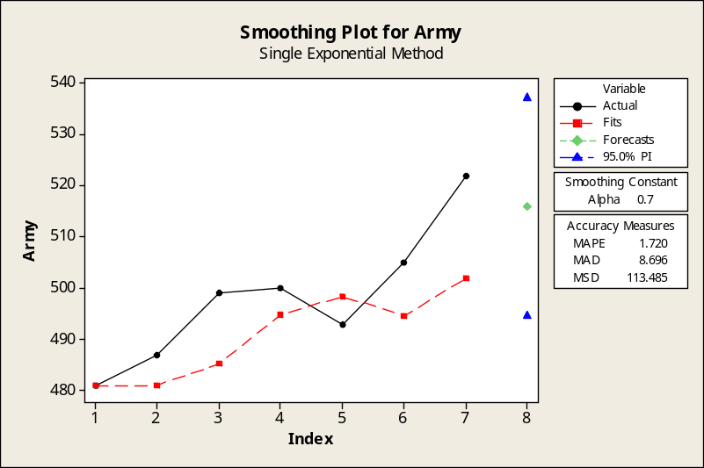

18.61 p/c/m The Minitab quadratic trend equation and plot are shown below. For 1985 coded as x = 1, the quadratic trend equation is Restaurants = -1408.0 + 1206.50x - 9.929x². For 2014, x = 30 and the forecast for 2014 is -1408.0 + 1206.50(30) - 9.929(30)² = 25,851 Subway restaurants.

Regression Analysis: Restaurants versus YrCode, YrCode_sq

The regression equation is Restaurants = - 1408 + 1207 YrCode - 9.93 YrCode_sq

Predictor Coef SE Coef T P
Constant -1408.0 404.5 -3.48 0.003
YrCode 1206.50 98.01 12.31 0.000
YrCode_sq -9.929 5.012 -1.98 0.066

S = 509.599 R-Sq = 99.2% R-Sq(adj) = 99.1%

Analysis of Variance
Source DF SS MS F P
Regression 2 502972400 251486200 968.40 0.000
Residual Error 15 3895370 259691
Total 17 506867770

Unusual Observations
Obs YrCode Restaurants Fit SE Fit Residual St Resid
1 1.0 596 -211 324 807 2.05R
R denotes an observation with a large standardized residual.

Predicted Values for New Observations
New
Obs Fit SE Fit 95% CI 95% PI
1 25851 2031 (21521, 30181) (21387, 30315)XX
XX denotes a point that is an extreme outlier in the predictors.

Values of Predictors for New Observations
New
Obs YrCode YrCode_sq
1 30.0 900

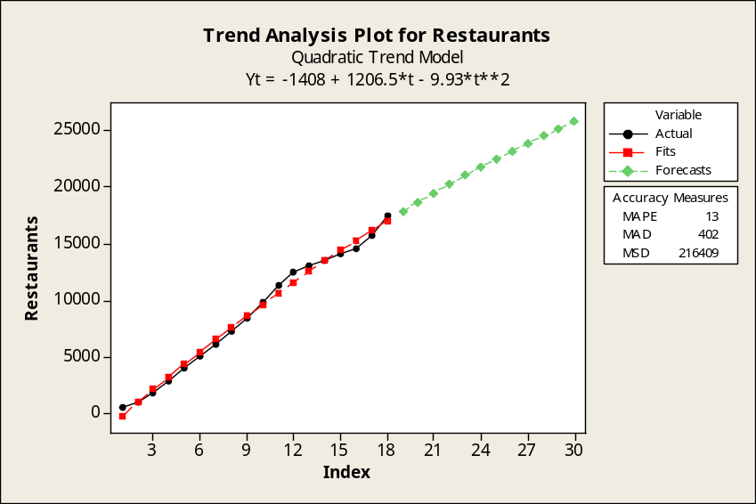

18.62 p/a/m The Minitab printout is shown below. Refer to the "Predict” column of the printout.

Single Exponential Smoothing for Restaurants

Data Restaurants
Length 18

Smoothing Constant Alpha 0.8

Time Restaurants Smooth Predict Error
1 596 596.0 596.0 0.00
2 991 912.0 596.0 395.00
3 1810 1630.4 912.0 898.00
4 2888 2636.5 1630.4 1257.60
5 4071 3784.1 2636.5 1434.52
6 5144 4872.0 3784.1 1359.90
7 6187 5924.0 4872.0 1314.98
8 7327 7046.4 5924.0 1403.00
9 8450 8169.3 7046.4 1403.60
10 9893 9548.3 8169.3 1723.72
11 11420 11045.7 9548.3 1871.74
12 12516 12221.9 11045.7 1470.35
13 13066 12897.2 12221.9 844.07
14 13600 13459.4 12897.2 702.81
15 14162 14021.5 13459.4 702.56
16 14662 14533.9 14021.5 640.51
17 15762 15516.4 14533.9 1228.10
18 17482 17088.9 15516.4 1965.62

Forecasts
Period Forecast Lower Upper
19 17088.9 14282.8 19894.9

Calculations are: (next period forecast) = 0.8(this period actual) + 0.2(this period forecast).
Thus, the forecast for period 19 (2003) would be 0.8(actual in period 18) + 0.3(forecast for period 18),
or 0.8(17482) + 0.2(15516.4) = 17,088.9 restaurants. The plot of forecast values is shown below.

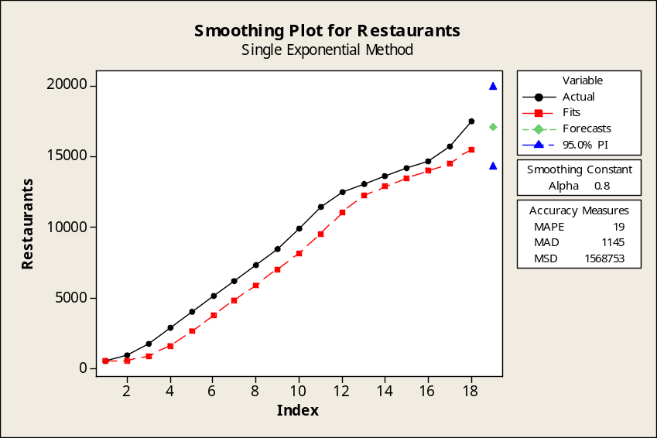

18.63 p/c/m
a. Linear trend equation. With 2001 coded as x = 1, the equation is AvgBill = 31.4743 + 1.62536x.
The forecast for 2015 (period 15) is 31.4743 + 1.62536(15) = $55.855. The Minitab trend analysis
and plot are shown below.

Regression Analysis: AvgBill versus YearCode

The regression equation is AvgBill = 31.5 + 1.63 YearCode

Predictor Coef SE Coef T P
Constant 31.4743 0.1506 208.99 0.000
YearCode 1.62536 0.03368 48.26 0.000

S = 0.178195 R-Sq = 99.8% R-Sq(adj) = 99.7%

Analysis of Variance
Source DF SS MS F P
Regression 1 73.970 73.970 2329.50 0.000
Residual Error 5 0.159 0.032
Total 6 74.129

Predicted Values for New Observations
New
Obs Fit SE Fit 95% CI 95% PI
1 55.8546 0.3765 (54.8868, 56.8225) (54.7839, 56.9254)XX
XX denotes a point that is an extreme outlier in the predictors.

Values of Predictors for New Observations
New
Obs YearCode
1 15.0

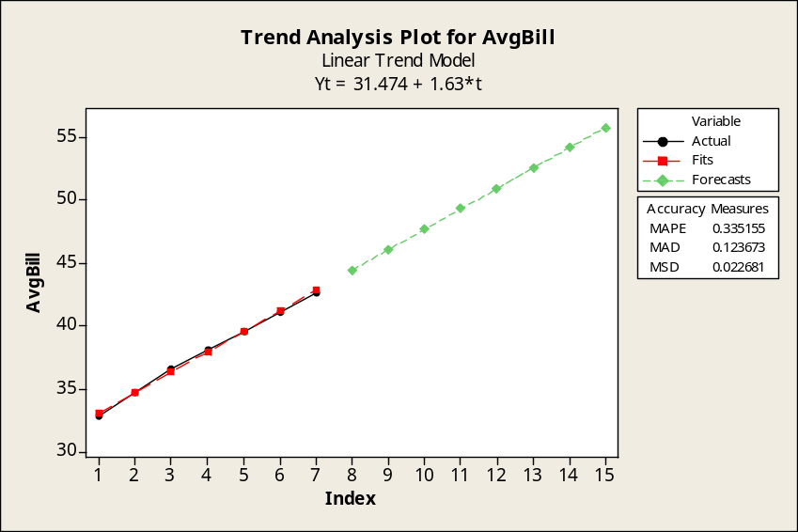

b. Quadratic trend equation. With 2001 coded as x = 1, the equation is
AvgBill = 31.0071 + 1.93679x - 0.038929x². As shown in the Minitab forecast below, the forecast
for 2015 (period 15) is 31.0071 + 1.93679(15) - 0.038929(15)² = $51.300. The printout and plot are
below.

Regression Analysis: AvgBill versus YearCode, YearCode_sq

The regression equation is AvgBill = 31.0 + 1.94 YearCode - 0.0389 YearCode_sq

Predictor Coef SE Coef T P
Constant 31.0071 0.1382 224.31 0.000
YearCode 1.93679 0.07922 24.45 0.000
YearCode_sq -0.038929 0.009678 -4.02 0.016

S = 0.0887009 R-Sq = 100.0% R-Sq(adj) = 99.9%

Analysis of Variance
Source DF SS MS F P
Regression 2 74.097 37.049 4708.86 0.000
Residual Error 4 0.031 0.008
Total 6 74.129

Predicted Values for New Observations
New
Obs Fit SE Fit 95% CI 95% PI
1 51.3000 1.1477 (48.1134, 54.4866) (48.1039, 54.4961)XX
XX denotes a point that is an extreme outlier in the predictors.

Values of Predictors for New Observations
New
Obs YearCode YearCode_sq
1 15.0 225

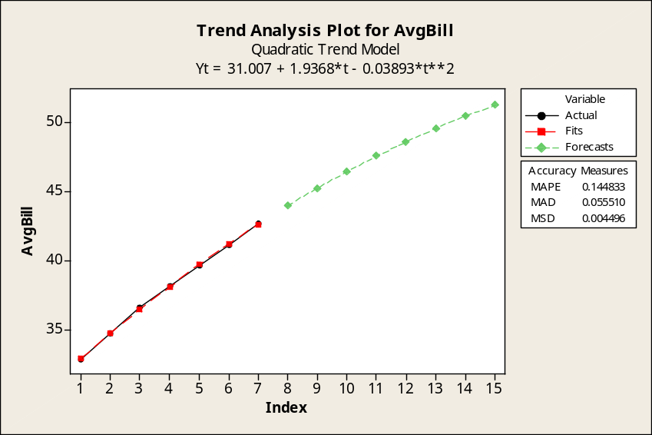

c. Referring to the Minitab plots in parts a and b, the MAD and MSE values are as shown below.
Note that Minitab shows MSE as "MSD".
Linear trend equation: MAD = 0.1237 MSE = 0.0227
Quadratic trend equation: MAD = 0.0555 MSE = 0.0045
On the basis of either MAD or MSE, the quadratic trend equation is the better fit to the data.

The comparable Excel trend equations and their plots are shown below.
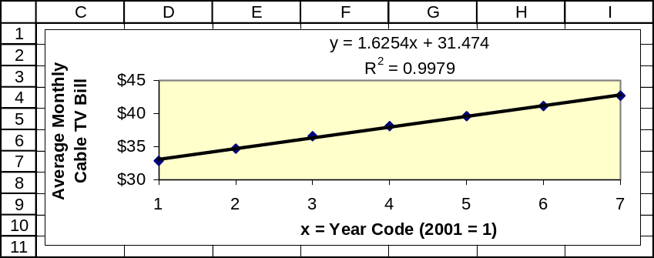

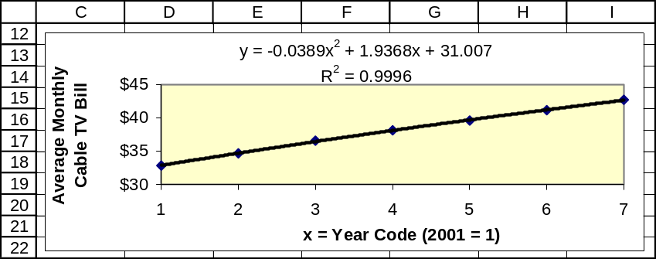

18.64 p/c/m
a. Linear trend equation. With 2000 coded as x = 1, the equation is Visitors = 42.661 + 1.1143x.
The forecast for 2015 (period 16) is 42.661 + 1.1143(16) = 60.5 million visitors. The Minitab
printout and plot are shown below.

Regression Analysis: Visitors versus YearCode

The regression equation is Visitors = 42.7 + 1.11 YearCode

Predictor Coef SE Coef T P
Constant 42.661 3.586 11.90 0.000
YearCode 1.1143 0.7100 1.57 0.168

S = 4.60157 R-Sq = 29.1% R-Sq(adj) = 17.3%

Analysis of Variance
Source DF SS MS F P
Regression 1 52.15 52.15 2.46 0.168
Residual Error 6 127.05 21.17
Total 7 179.19

Unusual Observations
Obs YearCode Visitors Fit SE Fit Residual St Resid
1 1.00 50.90 43.78 2.97 7.12 2.03R
R denotes an observation with a large standardized residual.

Predicted Values for New Observations
New
Obs Fit SE Fit 95% CI 95% PI
1 60.49 8.33 (40.12, 80.86) (37.21, 83.77)XX
XX denotes a point that is an extreme outlier in the predictors.

Values of Predictors for New Observations
New
Obs YearCode
1 16.0

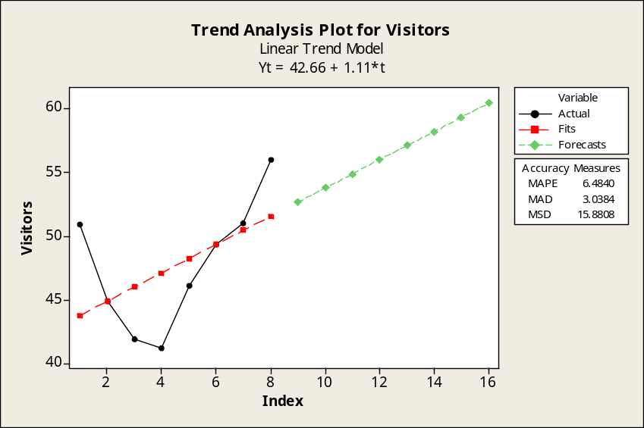

b. Quadratic trend equation. With 2000 coded as x = 1, the equation is
Visitors = 54.607 - 6.054x +0.7964x². The forecast for 2015 (period 16) is
54.607 - 6.054(16) +0.7964(16)² = 161.6 million visitors. The Minitab printout and plot are shown below.

Regression Analysis: Visitors versus YearCode, YearCode_sq

The regression equation is Visitors = 54.6 - 6.05 YearCode + 0.796 YearCode_sq

Predictor Coef SE Coef T P
Constant 54.607 2.824 19.34 0.000
YearCode -6.054 1.440 -4.20 0.008
YearCode_sq 0.7964 0.1562 5.10 0.004

S = 2.02407 R-Sq = 88.6% R-Sq(adj) = 84.0%

Analysis of Variance
Source DF SS MS F P
Regression 2 158.711 79.355 19.37 0.004
Residual Error 5 20.484 4.097
Total 7 179.195

Predicted Values for New Observations
New
Obs Fit SE Fit 95% CI 95% PI
1 161.636 20.168 (109.793, 213.478) (109.533, 213.739)XX
XX denotes a point that is an extreme outlier in the predictors.

Values of Predictors for New Observations
New
Obs YearCode YearCode_sq
1 16.0 256

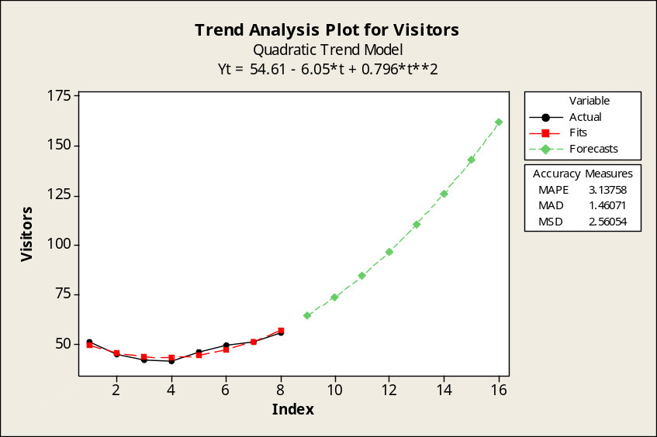

c. Referring to the Minitab plots in parts a and b, the MAD and MSE values are as shown below.
Note that Minitab shows MSE as "MSD".
Linear trend equation: MAD = 3.0384 MSE = 15.8808
Quadratic trend equation: MAD = 1.4607 MSE = 2.5605
On the basis of either MAD or MSE, the quadratic trend equation is the better fit to the data.

The comparable Excel trend equations and their plots are shown below.
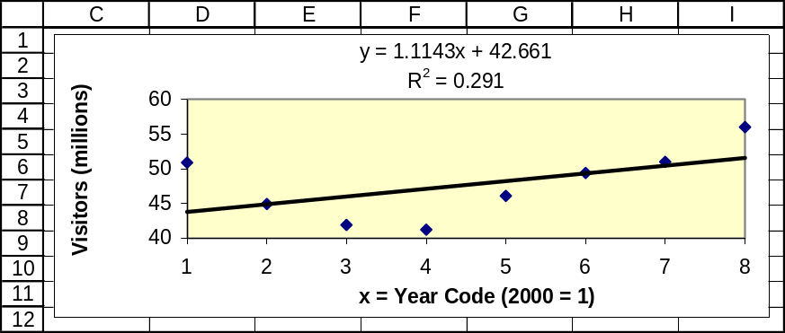

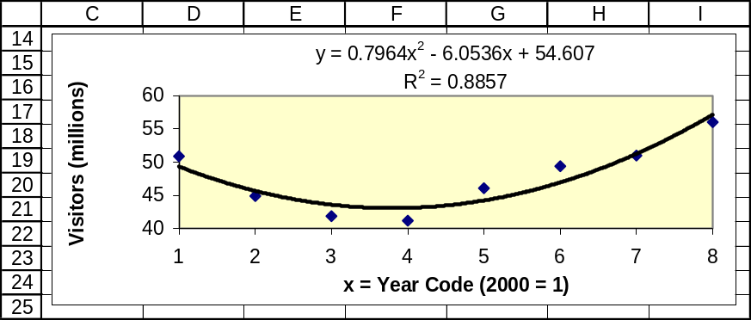

18.65 p/a/m
a. The graph is shown along with the 3-period centered moving average in part b. The overall trend appears to be very slightly upward over the years reflected by the data.
b. Three-period centered moving average. Using Minitab, the underlying values and graph for the moving average with N = 3 are shown below. Refer to the "MA" column for the centered moving average values.

Moving Average for Sales

Moving Average Length 3

Time Sales MA Predict Error
1 72.3 * * *
2 78.0 80.000 * *
3 89.7 89.167 80.000 9.7000
4 99.8 95.767 89.167 10.6333
5 97.8 96.833 95.767 2.0333
6 92.9 98.100 96.833 -3.9333
7 103.6 101.433 98.100 5.5000
8 107.8 110.800 101.433 6.3667
9 121.0 113.533 110.800 10.2000
10 111.8 112.867 113.533 -1.7333
11 105.8 105.867 112.867 -7.0667
12 100.0 97.500 105.867 -5.8667
13 86.7 93.533 97.500 -10.8000
14 93.9 85.933 93.533 0.3667
15 77.2 90.333 85.933 -8.7333
16 99.9 92.233 90.333 9.5667
17 99.6 91.067 92.233 7.3667
18 73.7 * 91.067 -17.3667

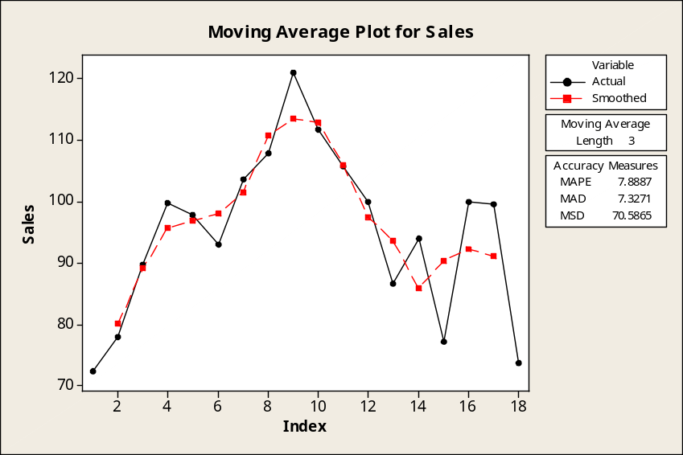

c. Exponentially smoothed curve, using Minitab and with smoothing constant α = 0.3. Refer to the "Smooth" column for the smoothed values.

Single Exponential Smoothing for Sales

Smoothing Constant Alpha 0.3

Time Sales Smooth Predict Error
1 72.3 72.300 72.300 0.0000
2 78.0 74.010 72.300 5.7000
3 89.7 78.717 74.010 15.6900
4 99.8 85.042 78.717 21.0830
5 97.8 88.869 85.042 12.7581
6 92.9 90.079 88.869 4.0307
7 103.6 94.135 90.079 13.5215
8 107.8 98.234 94.135 13.6650
9 121.0 105.064 98.234 22.7655
10 111.8 107.085 105.064 6.7359
11 105.8 106.699 107.085 -1.2849
12 100.0 104.690 106.699 -6.6994
13 86.7 99.293 104.690 -17.9896
14 93.9 97.675 99.293 -5.3927
15 77.2 91.532 97.675 -20.4749
16 99.9 94.043 91.532 8.3676
17 99.6 95.710 94.043 5.5573
18 73.7 89.107 95.710 -22.0099

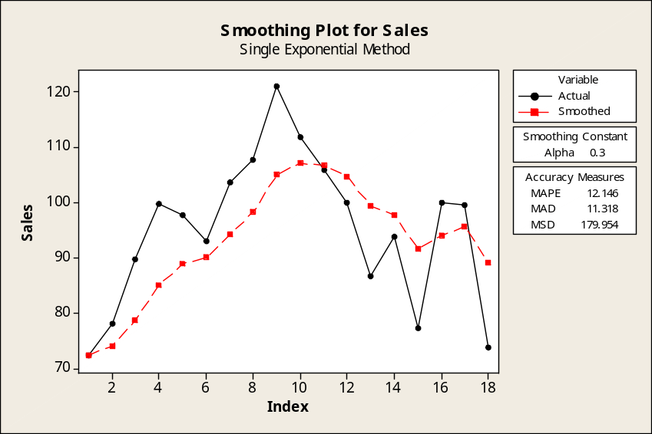

d. Fitting an exponentially smoothed curve with α = 0.7. As expected, the larger smoothing constant leads to a curve that follows the data more closely, but is not as smooth.
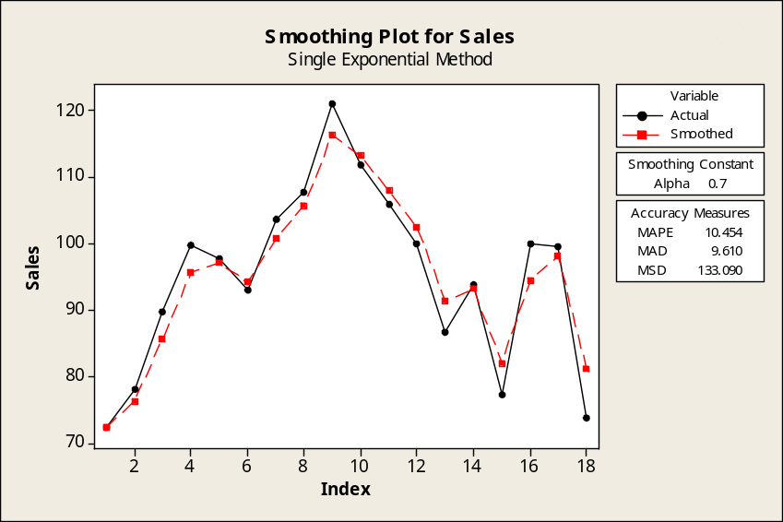

18.66 p/a/m Using Minitab, the calculation summary is shown below. Refer to the "Predict" column of the printout. The years are coded so that 1991 is period 1.

Single Exponential Smoothing for Sales

Smoothing Constant Alpha 0.5

Time Sales Smooth Predict Error
1 72.3 72.300 72.300 0.0000
2 78.0 75.150 72.300 5.7000
3 89.7 82.425 75.150 14.5500
4 99.8 91.113 82.425 17.3750
5 97.8 94.456 91.113 6.6875
6 92.9 93.678 94.456 -1.5563
7 103.6 98.639 93.678 9.9219
8 107.8 103.220 98.639 9.1609
9 121.0 112.110 103.220 17.7805
10 111.8 111.955 112.110 -0.3098
11 105.8 108.877 111.955 -6.1549
12 100.0 104.439 108.877 -8.8774
13 86.7 95.569 104.439 -17.7387
14 93.9 94.735 95.569 -1.6694
15 77.2 85.967 94.735 -17.5347
16 99.9 92.934 85.967 13.9327
17 99.6 96.267 92.934 6.6663
18 73.7 84.983 96.267 -22.5668

Forecasts
Period Forecast Lower Upper
19 84.9834 60.7312 109.236

Calculations are: (next period forecast) = 0.5(this period actual) + 0.5(this period forecast).
Thus, the forecast for period 19 (2009) would be 0.5(actual in period 18) + 0.5(forecast for period 18),
or 0.5(73.7) + 0.5(96.267) = 84.98 thousand boats. The graphical counterpart is shown below.

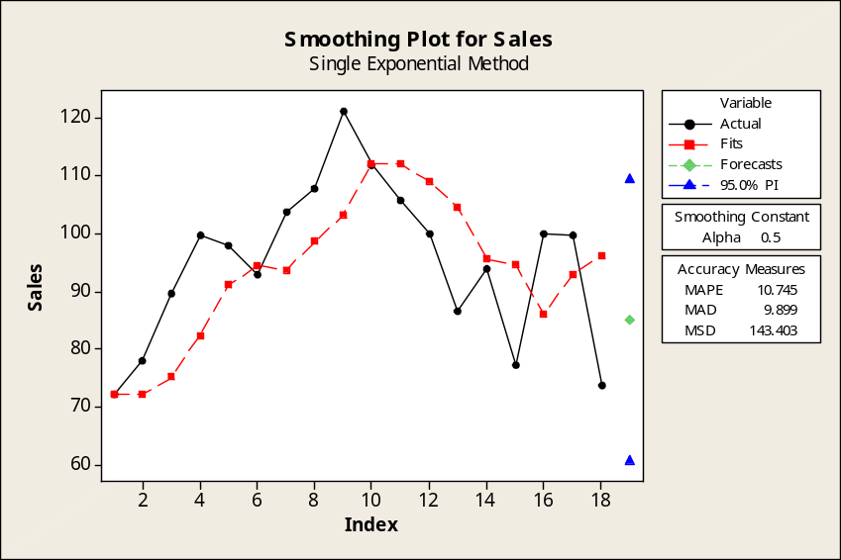

18.67 p/a/m For this seasonal index problem involving quarterly data, we will use Excel worksheet template tmquarts. The steps for its use are described in the worksheet template. The graphical summary of the solution is shown below the calculation results.
The seasonal indexes are: I, 95.14; II, 89.69; III, 95.64; IV, 119.53
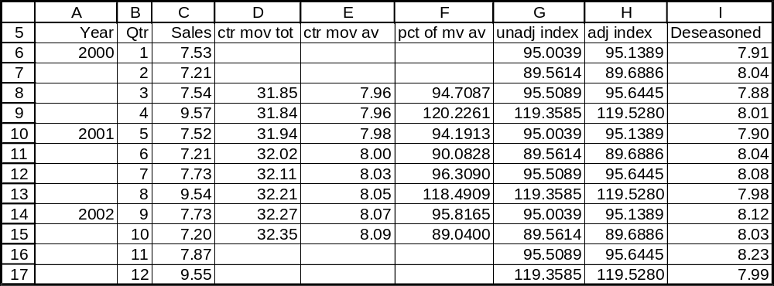

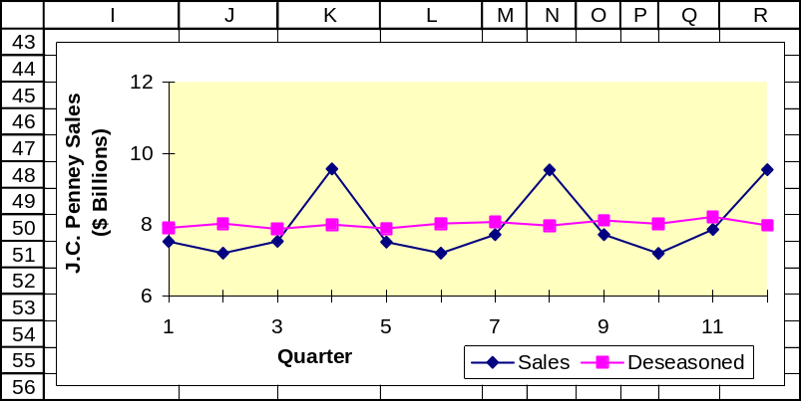

18.68 p/a/m We will use Minitab for the underlying calculations and plots for J.C. Penney quarterly sales data in exercise 18.67. The three-period centered moving average and plot are shown below.

Moving Average for Sales

Moving Average Length 3

Time Sales MA Predict Error
1 7.53 * * *
2 7.21 7.42667 * *
3 7.54 8.10667 7.42667 0.11333
4 9.57 8.21000 8.10667 1.46333
5 7.52 8.10000 8.21000 -0.69000
6 7.21 7.48667 8.10000 -0.89000
7 7.73 8.16000 7.48667 0.24333
8 9.54 8.33333 8.16000 1.38000
9 7.73 8.15667 8.33333 -0.60333
10 7.20 7.60000 8.15667 -0.95667
11 7.87 8.20667 7.60000 0.27000
12 9.55 * 8.20667 1.34333

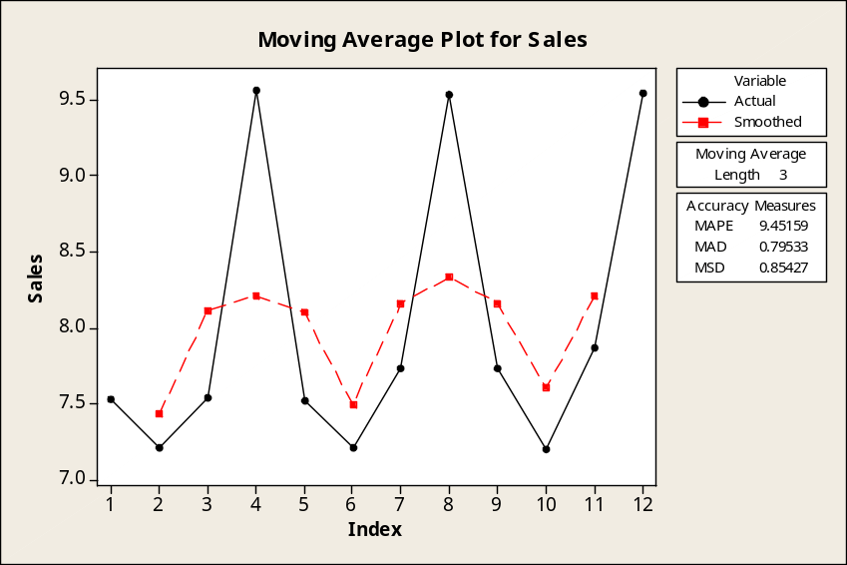

Four-period centered moving average.

Moving Average for Sales

Moving Average Length 4

Time Sales MA Predict Error
1 7.53 * * *
2 7.21 * * *
3 7.54 7.96125 * *
4 9.57 7.96000 7.96125 1.60875
5 7.52 7.98375 7.96000 -0.44000
6 7.21 8.00375 7.98375 -0.77375
7 7.73 8.02625 8.00375 -0.27375
8 9.54 8.05125 8.02625 1.51375
9 7.73 8.06750 8.05125 -0.32125
10 7.20 8.08625 8.06750 -0.86750
11 7.87 * 8.08625 -0.21625
12 9.55 * 8.08625 1.46375

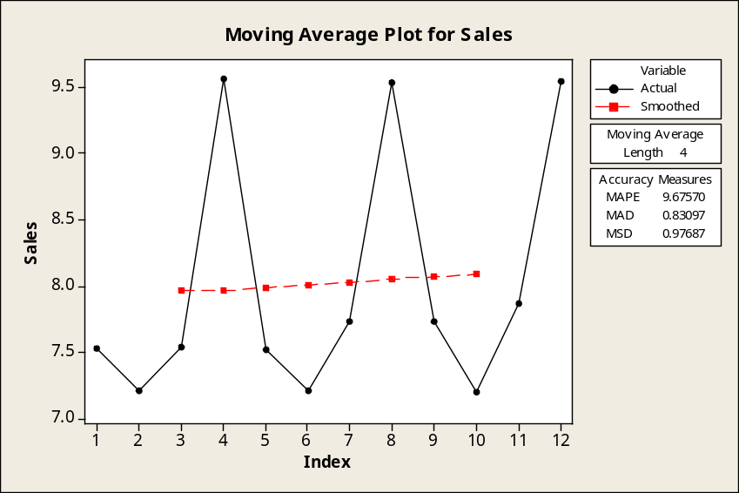

As expected, the four-period centered moving average is much smoother than when N = 3 periods. There are four quarters in a year, and a retailer like J.C. Penney experiences a very strong level of sales in the fourth quarter of each year. In a four-period centered moving average, each quarter of the year is represented once in the basis for each smoothed value. Other companies for whom this type of pattern would be typical would be Sears, Wal-Mart, and others who depend heavily on the holiday buying season during the fourth quarter of the calendar year.

18.69 p/a/m For this seasonal index problem involving quarterly data, we will use Excel worksheet template tmquarts. The procedure is described in the worksheet template. The graphical summary of the solution is shown below the calculation results. The seasonal indexes are: I, 192.88; II, 63.87;
III, 30.14; IV, 113.11.
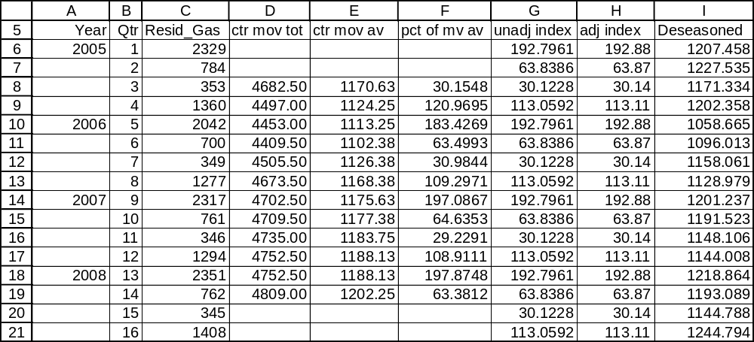

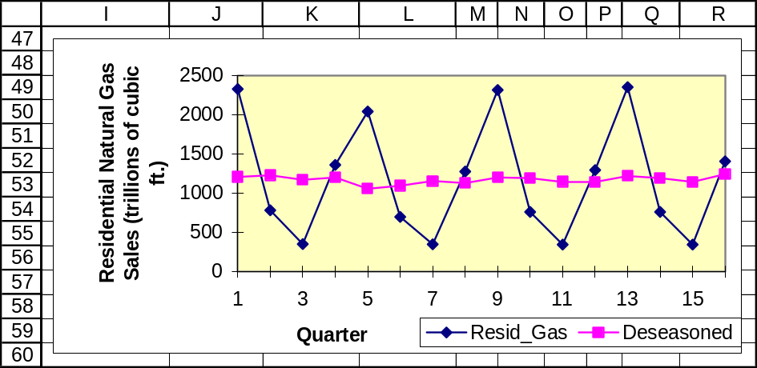

18.70 p/a/m We will use Minitab for the underlying calculations and plots for the natural gas sales data in exercise 18.69.

The four-period centered moving average and plot.

Moving Average for Resid_Gas

Moving Average Length 4

Time Resid_Gas MA Predict Error
1 2329 * * *
2 784 * * *
3 353 1170.63 * *
4 1360 1124.25 1170.63 189.38
5 2042 1113.25 1124.25 917.75
6 700 1102.38 1113.25 -413.25
7 349 1126.38 1102.38 -753.38
8 1277 1168.38 1126.38 150.63
9 2317 1175.63 1168.38 1148.63
10 761 1177.38 1175.63 -414.63
11 346 1183.75 1177.38 -831.38
12 1294 1188.13 1183.75 110.25
13 2351 1188.13 1188.13 1162.88
14 762 1202.25 1188.13 -426.13
15 345 * 1202.25 -857.25
16 1408 * 1202.25 205.75

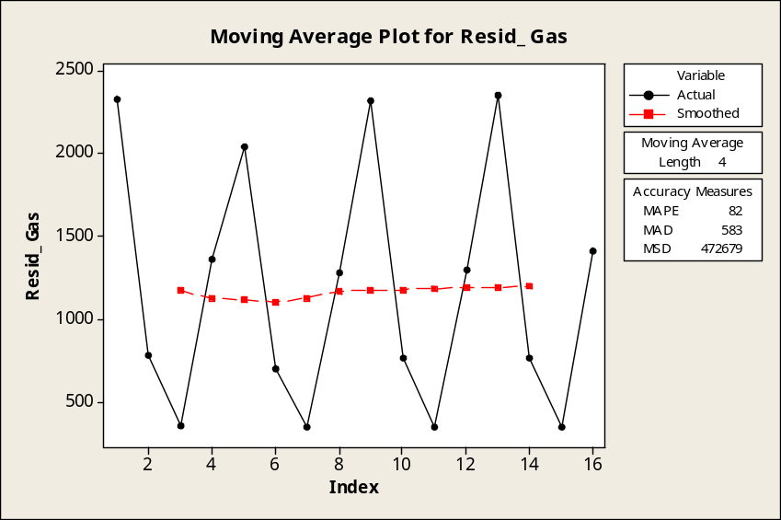

The five-period centered moving average and plot.

Moving Average for Resid_Gas

Moving Average Length 5

Time Resid_Gas MA Predict Error
1 2329 * * *
2 784 * * *
3 353 1373.6 * *
4 1360 1047.8 * *
5 2042 960.8 1373.6 668.4
6 700 1145.6 1047.8 -347.8
7 349 1337.0 960.8 -611.8
8 1277 1080.8 1145.6 131.4
9 2317 1010.0 1337.0 980.0
10 761 1199.0 1080.8 -319.8
11 346 1413.8 1010.0 -664.0
12 1294 1102.8 1199.0 95.0
13 2351 1019.6 1413.8 937.2
14 762 1232.0 1102.8 -340.8
15 345 * 1019.6 -674.6
16 1408 * 1232.0 176.0

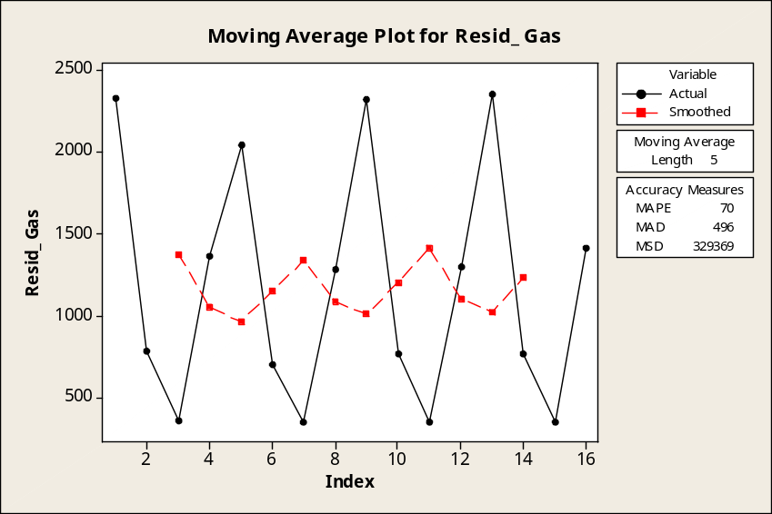

Using N = 5 instead of N = 4 often leads to a smoother fitted curve. However, the four-period centered moving average is much smoother here because of the strong seasonal pattern of residential gas sales. Other energy industries likely to experience such a strong seasonal pattern would include the coal, gasoline, diesel fuel, and heating oil industries.

18.71 p/a/m For this seasonal index problem involving quarterly data, we will use Excel worksheet template tmquarts. The procedure is described in the worksheet template. The graphical summary of the solution is shown below the calculation results. The seasonal indexes are: I, 94.68; II, 93.54;
III, 111.05; IV, 100.73.
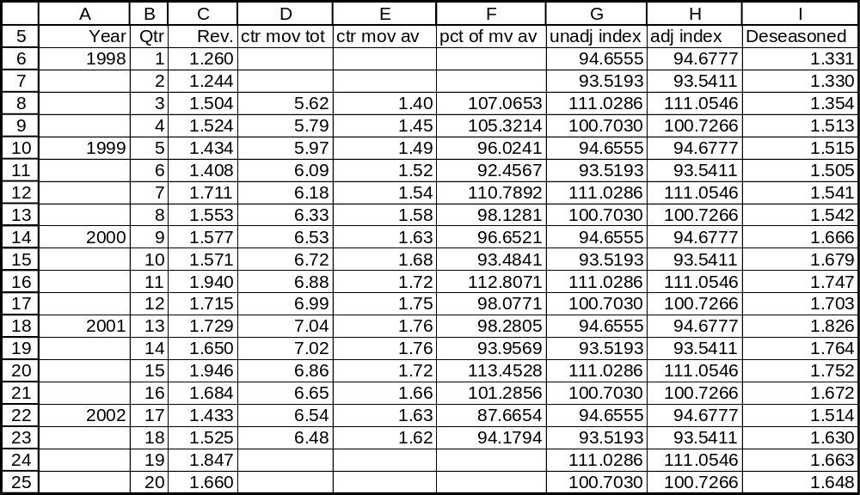

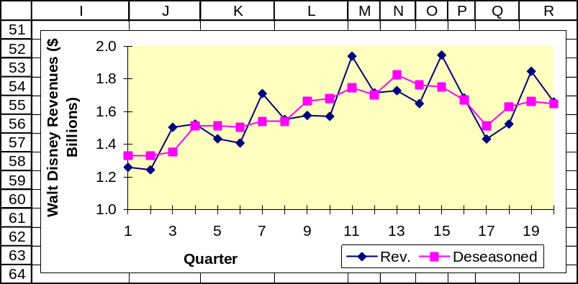

18.72 p/a/m The four-quarter centered moving average and plot are shown below. Examples of other entertainment or recreation companies for whom a four-period moving average might have such a great effect on smoothing quarterly revenue data could include the Universal Studios theme park, Sea World in Orlando, and various ski resorts in the U.S. and around the world.

Moving Average for Revenue

Moving Average Length 4

Time Revenue MA Predict Error
1 1.260 * * *
2 1.244 * * *
3 1.504 1.40475 * *
4 1.524 1.44700 1.40475 0.119250
5 1.434 1.49337 1.44700 -0.013000
6 1.408 1.52288 1.49337 -0.085375
7 1.711 1.54438 1.52288 0.188125
8 1.553 1.58263 1.54438 0.008625
9 1.577 1.63163 1.58263 -0.005625
10 1.571 1.68050 1.63163 -0.060625
11 1.940 1.71975 1.68050 0.259500
12 1.715 1.74863 1.71975 -0.004750
13 1.729 1.75925 1.74863 -0.019625
14 1.650 1.75612 1.75925 -0.109250
15 1.946 1.71525 1.75612 0.189875
16 1.684 1.66262 1.71525 -0.031250
17 1.433 1.63463 1.66262 -0.229625
18 1.525 1.61925 1.63463 -0.109625
19 1.847 * 1.61925 0.227750
20 1.660 * 1.61925 0.040750

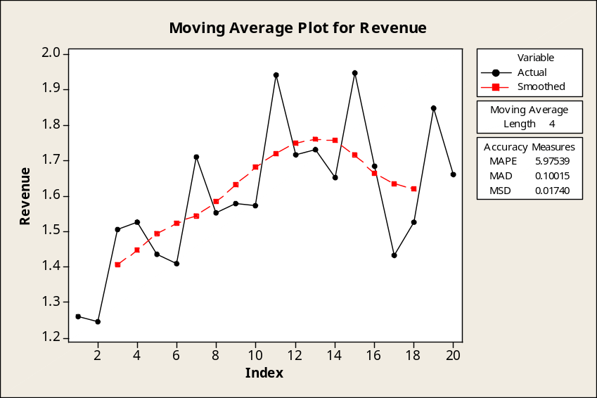

The five-quarter centered moving average and plot.

Moving Average for Revenue

Moving Average Length 5

Time Revenue MA Predict Error
1 1.260 * * *
2 1.244 * * *
3 1.504 1.3932 * *
4 1.524 1.4228 * *
5 1.434 1.5162 1.3932 0.0408
6 1.408 1.5260 1.4228 -0.0148
7 1.711 1.5366 1.5162 0.1948
8 1.553 1.5640 1.5260 0.0270
9 1.577 1.6704 1.5366 0.0404
10 1.571 1.6712 1.5640 0.0070
11 1.940 1.7064 1.6704 0.2696
12 1.715 1.7210 1.6712 0.0438
13 1.729 1.7960 1.7064 0.0226
14 1.650 1.7448 1.7210 -0.0710
15 1.946 1.6884 1.7960 0.1500
16 1.684 1.6476 1.7448 -0.0608
17 1.433 1.6870 1.6884 -0.2554
18 1.525 1.6298 1.6476 -0.1226
19 1.847 * 1.6870 0.1600
20 1.660 * 1.6298 0.0302

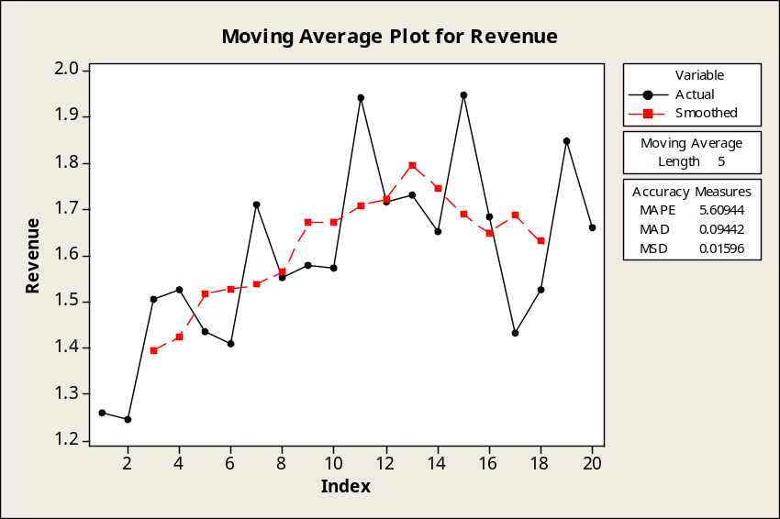

18.73 p/a/e The seasonal index = (actual data / deseasonalized data) * 100. The seasonal indexes are:
I: (1682/2320) * 100 = 72.50 II: (1963/2362) * 100 = 83.11
III: (2451/2205) * 100 = 111.16 IV: (3205/2414) * 100 = 132.77

18.74 p/a/m If x = 1 for 1997, then x = 18 for 2014. Therefore, the forecasted number of vehicles using the ferry for all of 2014 is 2050 + 12(18) = 2266. Using the seasonal indexes provided yields the estimates for quarterly usage:
I: (2266/4) * ( 55/100) = 311.575, or 312 II: (2266/4) * (130/100) = 736.450, or 736
III: (2266/4) * (145/100) = 821.425, or 821 IV: (2266/4) * ( 70/100) = 396.550, or 397

18.75 p/a/m If x = 1 for 2001, then x = 15 for 2015. Therefore, the forecasted unit sales for the filtering system component for all of 2015 is 150 + 12(15) + 0.01(15)² = 332.25 (or 332 since this is a discrete variable). Using the seasonal indexes provided yields the estimates for quarterly sales:
I: (332/4) * ( 85/100) = 70.55, or 71 II: (332/4) * (110/100) = 91.30, or 91
III: (332/4) * (125/100) = 103.75, or 104 IV: (332/4) * ( 80/100) = 66.40, or 66

18.76 p/c/m
a. Linear trend equation. With 2003 coded as x = 1, the equation is $/Gallon = 3.916 + 0.60257x.
The forecast for 2014 (period 12) is 3.916 + 0.60257(12) = $11.15 per gallon. The Minitab printout and plot are shown below.

Regression Analysis: $/Gallon versus YrCode

The regression equation is $/Gallon = 3.92 + 0.603 YrCode

Predictor Coef SE Coef T P
Constant 3.9160 0.1869 20.95 0.000
YrCode 0.60257 0.04799 12.56 0.000

S = 0.200770 R-Sq = 97.5% R-Sq(adj) = 96.9%

Analysis of Variance
Source DF SS MS F P
Regression 1 6.3541 6.3541 157.64 0.000
Residual Error 4 0.1612 0.0403
Total 5 6.5154

Predicted Values for New Observations
New
Obs Fit SE Fit 95% CI 95% PI
1 11.1469 0.4161 (9.9916, 12.3021) (9.8641, 12.4296)XX
XX denotes a point that is an extreme outlier in the predictors.

Values of Predictors for New Observations
New
Obs YrCode
1 12.0

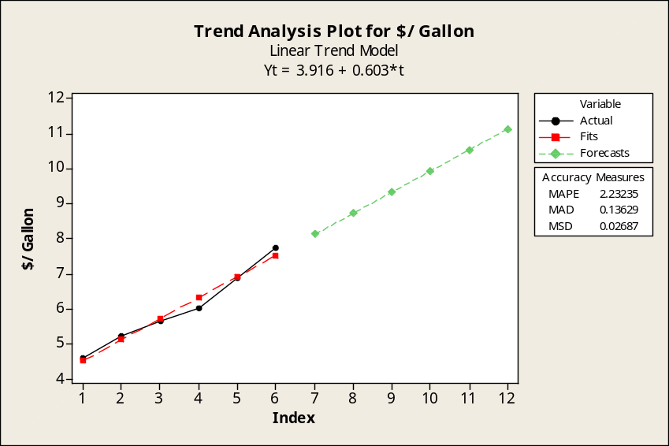

b. Quadratic trend equation. With 2003 coded as x = 1, the equation is
$/Gallon = 4.3860 + 0.2501x + 0.05036x². The forecast for 2014 (period 12) is
4.3860 + 0.2501(12) + 0.05036(12)² = $14.64 per gallon. The Minitab printout and plot
are shown below.

Regression Analysis: $/Gallon versus YrCode, YrCode_sq

The regression equation is $/Gallon = 4.39 + 0.250 YrCode + 0.0504 YrCode_sq

Predictor Coef SE Coef T P
Constant 4.3860 0.2665 16.46 0.000
YrCode 0.2501 0.1743 1.43 0.247
YrCode_sq 0.05036 0.02438 2.07 0.131

S = 0.148955 R-Sq = 99.0% R-Sq(adj) = 98.3%

Analysis of Variance
Source DF SS MS F P
Regression 2 6.4488 3.2244 145.32 0.001
Residual Error 3 0.0666 0.0222
Total 5 6.5154

Predicted Values for New Observations
New
Obs Fit SE Fit 95% CI 95% PI
1 14.6383 1.7182 (9.1702, 20.1064) (9.1497, 20.1269)XX
XX denotes a point that is an extreme outlier in the predictors.

Values of Predictors for New Observations
New
Obs YrCode YrCode_sq
1 12.0 144

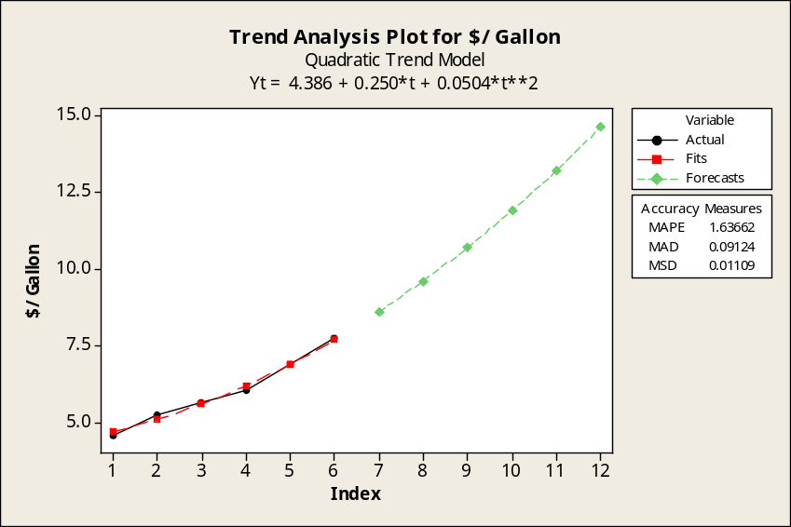

c. Referring to the Minitab plots in parts a and b, the MAD and MSE values are as shown below.
Note that Minitab shows MSE as "MSD".
Linear trend equation: MAD = 0.1363 MSE = 0.0269
Quadratic trend equation: MAD = 0.0912 MSE = 0.0111
On the basis of either MAD or MSE, the quadratic trend equation is the better fit to the data.
The comparable Excel trend equations and their plots are shown below.

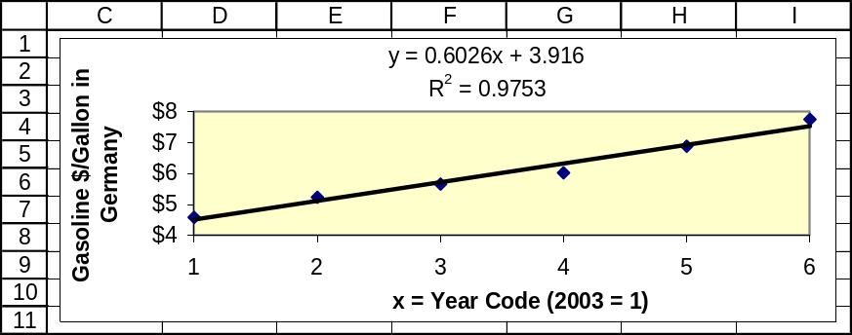
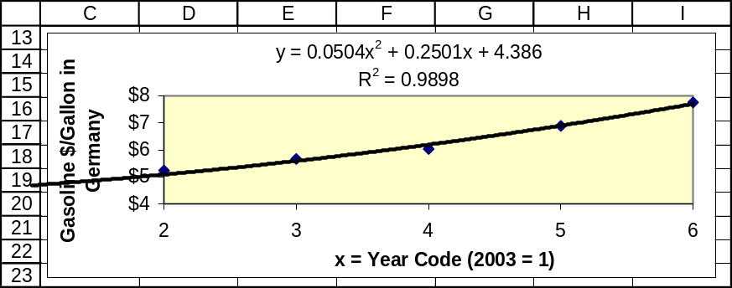

18.77 p/c/m
Quadratic trend equation.
With 1993 coded as x = 1, the equation is Cost = 38.3268 + 0.794341x + 0.0538258x².
The Minitab trend analysis plot is shown below.
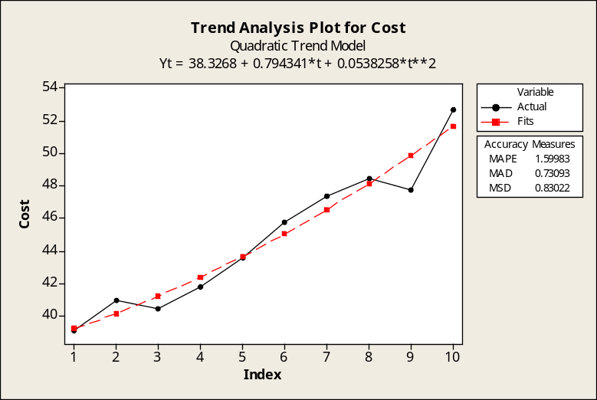

Linear trend equation.
With 1993 coded as x = 1, the equation is Cost = 37.1427 + 1.38642x . The Minitab trend analysis plot is shown below.
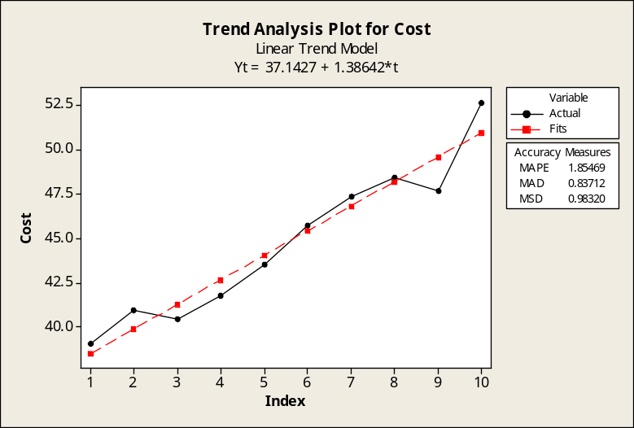

As shown in the information accompanying their respective plots, the quadratic trend equation has MSE = 0.83022 while the linear trend equation has MSE = 0.98320. (Recall that Minitab shows MSE as “MSD”.) The quadratic trend is the better fit to the data. The comparable Excel trend equations and their graphs are shown below.

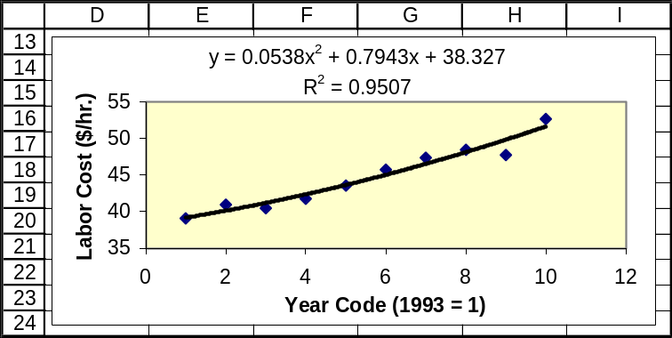

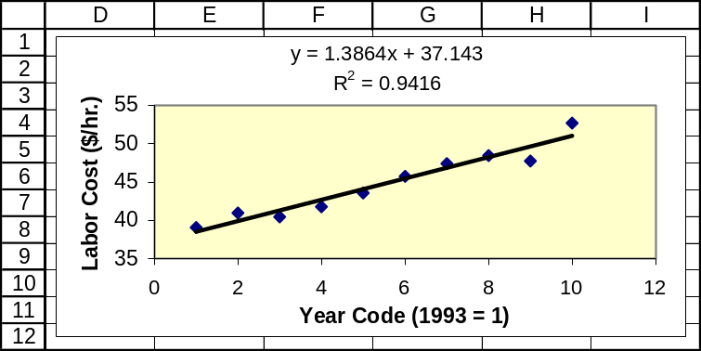

18.78 p/c/m
a. After combining the quarterly bookings into a total for each year, we can use Excel to determine the linear trend equation. With x = 1 for 2005, the equation is Passengers = 82.8 + 9.4x. For 2013, the year code will be x = 9 and the forecast will be Passengers = 82.8 + 9.4(9) = 167.4 thousand.
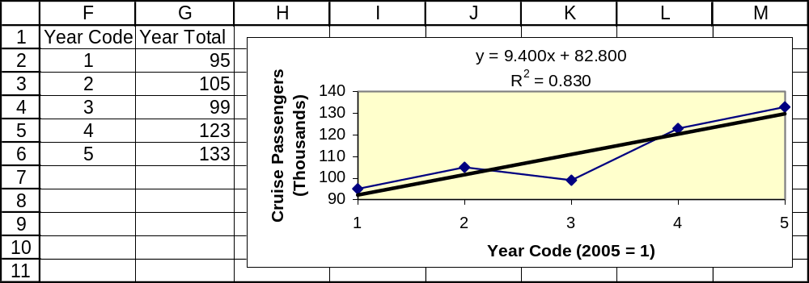

b. Using Excel worksheet template tmquarts, we can obtain the seasonal indexes.
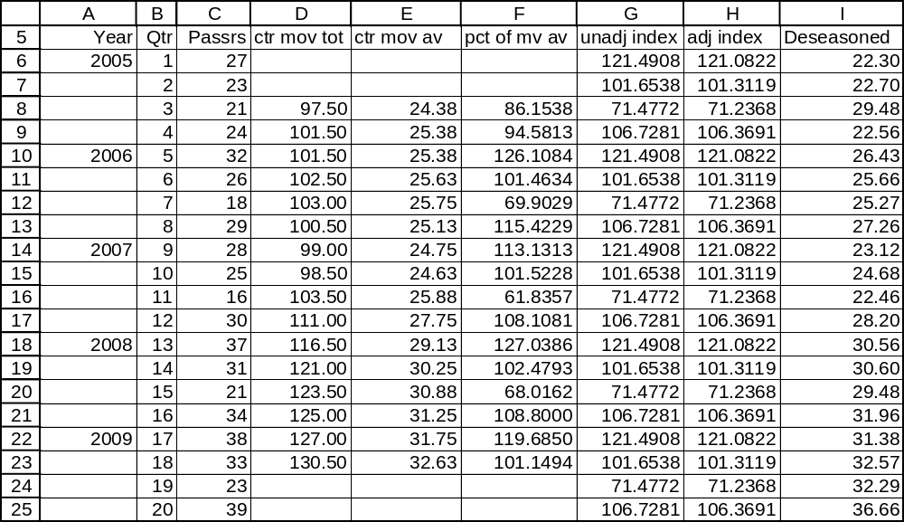

For 2013, the year code is x = 9 and the forecast is Passengers = 82.8 + 9.4(9) = 167.4 thousand.
The seasonal indexes are I: 121.0822; II: 101.3119; III: 71.2368; and IV: 106.3691. Breaking the total forecast for 2013 into its quarterly components:
I: (167.4/4)*(121.0822/100) = 50.673 thousand
II: (167.4/4)*(101.3119/100) = 42.399 thousand
III: (167.4/4)*(71.2368/100) = 29.813 thousand
IV: (167.4/4)*(106.3691/100) = 44.515 thousand

c. With Excel, we specify 0.7 as the "damping factor" (i.e., 1 - smoothing constant, α = 0.3).
Excel places each forecast next to the preceding period, so we must shift the forecasts down by one period. We manually insert the initial forecast (95.00) in cell Q2, click on the lower right corner of cell Q6, then autofill to cell Q7 to get the forecast for 2010, 113.90 thousand passengers.
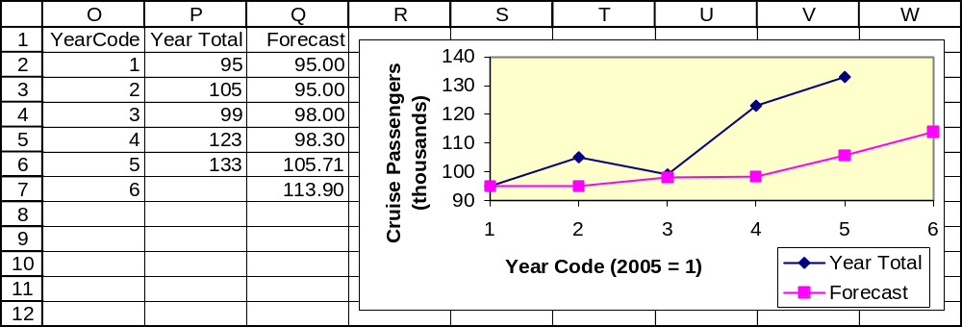

d. For 2010, the forecast is for 113.90 thousand passengers. The quarterly components are:
I: (113.9/4)*(121.0822/100) = 34.478 thousand
II: (113.9/4)*(101.3119/100) = 28.849 thousand
III: (113.9/4)*(71.2368/100) = 20.285 thousand
IV: (113.9/4)*(106.3691/100) = 30.289 thousand

18.79 p/c/m The deseasonalized values are shown in column I of the Excel printout for part b of exercise 18.78. The chart of the original and deseasonalized quarterly values is shown below.
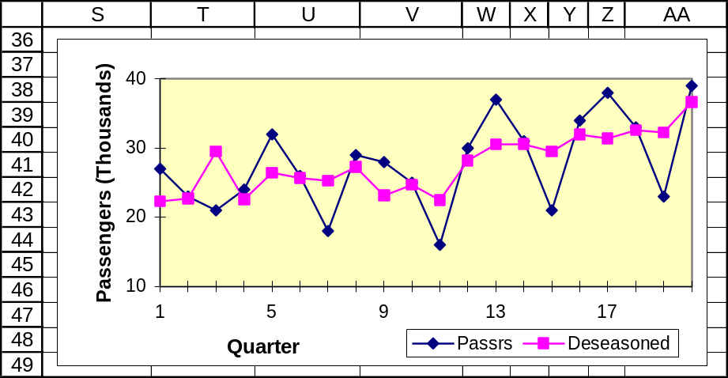

18.80 p/c/m
a. After combining the monthly loan applications into yearly totals, we can use Excel to determine the linear trend equation. With x = 1 for 2006, the equation is Applics = 353.5 + 28.3x.
The forecast for 2012 is Applics = 353.5 + 28.3(7) = 551.6 loan applications.
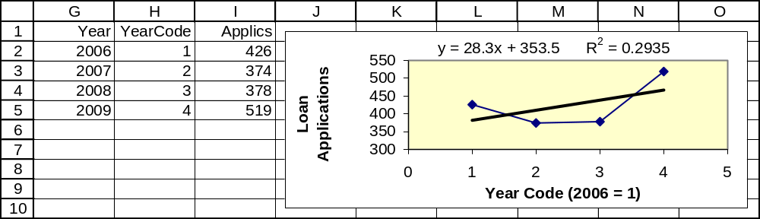

b. Using Excel worksheet template tmmonths, we can obtain the seasonal indexes.
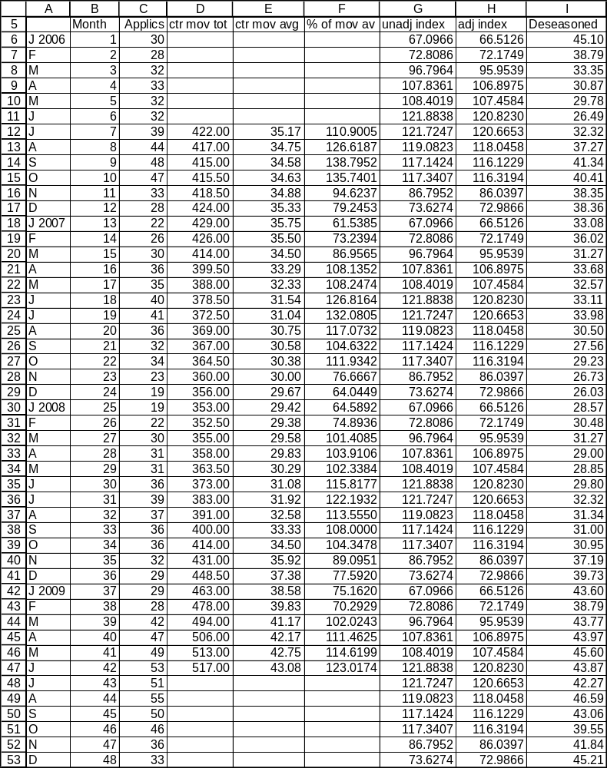

The seasonal indexes are:
J: 66.5126 F: 72.1749 M: 95.9539 A: 106.8975 M: 107.4584 J: 120.8230
J: 120.6653 A: 118.0458 S: 116.1229 O: 116.3194 N: 86.0397 D: 72.9866

Breaking the total forecast for 2012 into its monthly components:
J: (551.6/12)*(66.5126/100) = 30.57, or 31 applications
F: (551.6/12)*(72.1749/100) = 33.18, or 33
M: (551.6/12)*(95.9539/100) = 44.11, or 44
A: (551.6/12)*(106.8975/100) = 49.14, or 49
M: (551.6/12)*(107.4584/100) = 49.40, or 49
J: (551.6/12)*(120.8230/100) = 55.54, or 56
J: (551.6/12)*(120.6653/100) = 55.47, or 55
A: (551.6/12)*(118.0458/100) = 54.26, or 54
S: (551.6/12)*(116.1229/100) = 53.38, or 53
O: (551.6/12)*(116.3194/100) = 53.47, or 53
N: (551.6/12)*(86.0397/100) = 39.55, or 40
D: (551.6/12)*(72.9866/100) = 33.55, or 34

c. With Excel, we specify 0.6 as the "damping factor" (i.e., 1 - smoothing constant, α = 0.4).
Excel places each forecast next to the preceding period, so we must shift the forecasts down by one period. We manually insert the initial forecast (426.00) in cell K2, click on the lower right corner of cell K5, then autofill to cell K6 to get the forecast for 2010, which is 444.19 loan applications for the year. We then use Excel to generate the plot.
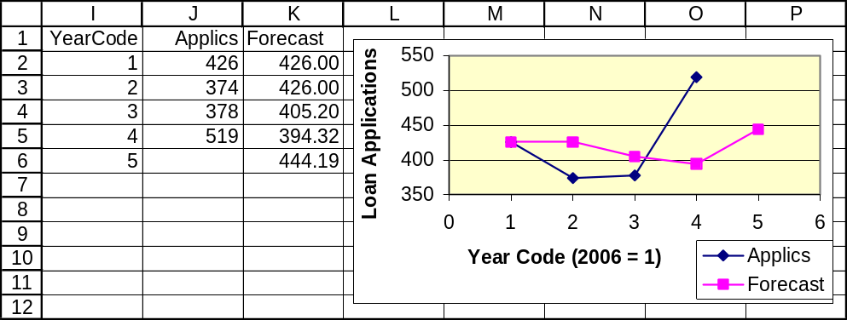

d. For 2010, the forecast is for 444.19 loan applications. Breaking the total forecast into its monthly components:
J: (444.19/12)*(66.5126/100) = 24.62, or 25 applications
F: (444.19/12)*(72.1749/100) = 26.72, or 27
M: (444.19/12)*(95.9539/100) = 35.52, or 36
A: (444.19/12)*(106.8975/100) = 39.57, or 40
M: (444.19/12)*(107.4584/100) = 39.78, or 40
J: (444.19/12)*(120.8230/100) = 44.72, or 45
J: (444.19/12)*(120.6653/100) = 44.67, or 45
A: (444.19/12)*(118.0458/100) = 43.70, or 44
S: (444.19/12)*(116.1229/100) = 42.98, or 43
O: (444.19/12)*(116.3194/100) = 43.06, or 43
N: (444.19/12)*(86.0397/100) = 31.85, or 32
D: (444.19/12)*(72.9866/100) = 27.02, or 27

18.81 p/c/m The deseasonalized values are shown in column I of the Excel printout for part b of exercise 18.80. The chart of the original and deseasonalized monthly values is shown below.
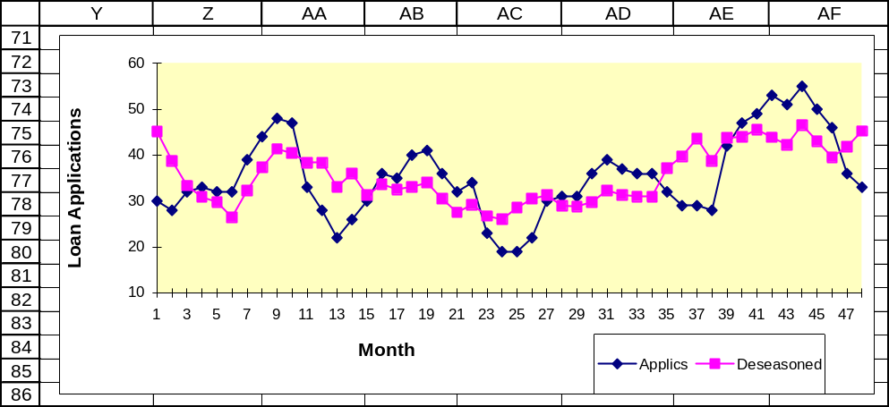

18.82 p/a/m The null and alternative hypotheses are H₀: ρ ≤ 0 and H₁: ρ > 0.
As shown in the Minitab printout below, the Durbin-Watson statistic is d = 0.796. In the Durbin-Watson table for α = 0.05 for a directional test, the listed values for n = 18 observations and k = 1 independent variable are d_{L} = 1.16 and d_{U} = 1.39. We are testing for positive autocorrelation, so the listed value of interest is d_{L} = 1.16. Because d = 0.796 is less than d_{L} = 1.16, there is evidence of positive autocorrelation at this level, and the linear model may not be appropriate for these data. (Refer to the “testing for positive autocorrelation” portion of Figure 18.5 in the text.)

Regression Analysis: Sales versus YrCode

The regression equation is Sales = 93.9 + 0.124 YrCode

Predictor Coef SE Coef T P
Constant 93.906 6.827 13.76 0.000
YrCode 0.1239 0.6307 0.20 0.847

S = 13.8825 R-Sq = 0.2% R-Sq(adj) = 0.0%

Analysis of Variance
Source DF SS MS F P
Regression 1 7.4 7.4 0.04 0.847
Residual Error 16 3083.6 192.7
Total 17 3091.0

Durbin-Watson statistic = 0.795754

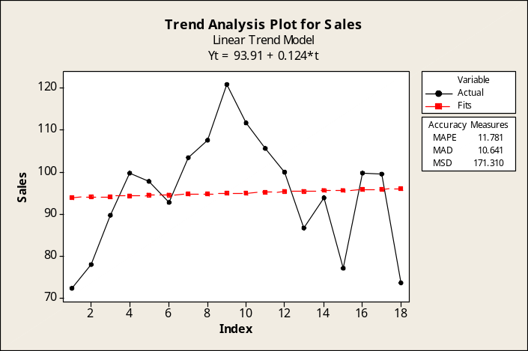
18.83 p/a/m The null and alternative hypotheses are H₀: ρ ≤ 0 and H₁: ρ > 0.
As shown in the Minitab printout below, the Durbin-Watson statistic is d = 0.48. In the Durbin-Watson table for α = 0.05 for a directional test, the listed values for n = 18 observations and k = 1 independent variable are d_{L} = 1.16 and d_{U} = 1.39. We are testing for positive autocorrelation, so the listed value of interest is d_{L} = 1.16. Because d = 0.48 is less than d_{L} = 1.16, there is evidence of positive autocorrelation at this level, and the linear model may not be appropriate for these data. (Refer to the “testing for positive autocorrelation” portion of Figure 18.5 in the text.)

Regression Analysis: Restaurants versus YrCode

The regression equation is Restaurants = - 779 + 1018 YrCode

Predictor Coef SE Coef T P
Constant -779.2 272.5 -2.86 0.011
YrCode 1017.85 25.18 40.43 0.000

S = 554.209 R-Sq = 99.0% R-Sq(adj) = 99.0%

Analysis of Variance
Source DF SS MS F P
Regression 1 501953415 501953415 1634.24 0.000
Residual Error 16 4914356 307147
Total 17 506867770

Unusual Observations
Obs YrCode Restaurants Fit SE Fit Residual St Resid
12 12.0 12516 11435 145 1081 2.02R
R denotes an observation with a large standardized residual.

Durbin-Watson statistic = 0.480805

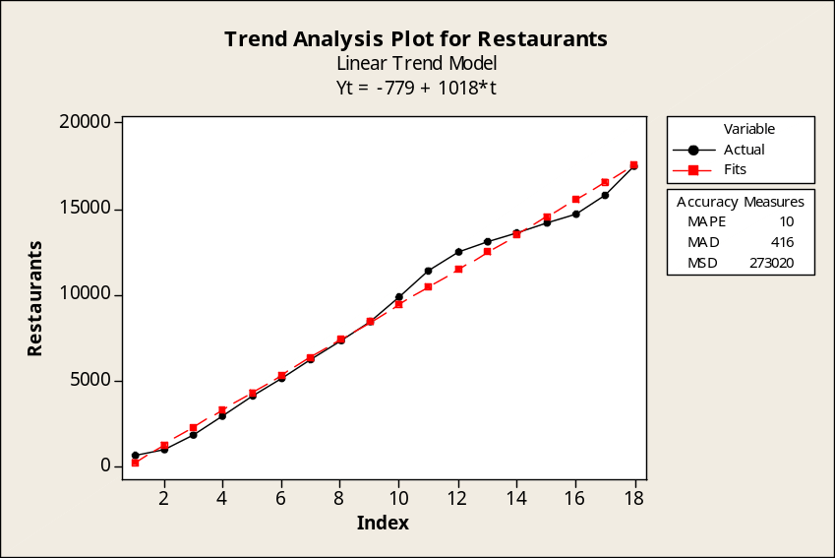

18.84 p/c/m The Minitab printout is shown below.

Regression Analysis: PPIt versus PPI_t-1

The regression equation is PPIt = - 2.19 + 1.04 PPI_t-1

27 cases used, 1 cases contain missing values

Predictor Coef SE Coef T P
Constant -2.194 3.571 -0.61 0.544
PPI_t-1 1.04352 0.02874 36.31 0.000

S = 2.95005 R-Sq = 98.1% R-Sq(adj) = 98.1%

Analysis of Variance
Source DF SS MS F P
Regression 1 11474 11474 1318.41 0.000
Residual Error 25 218 9
Total 26 11691

Unusual Observations
Obs PPI_t-1 PPIt Fit SE Fit Residual St Resid
2 89 96.600 90.261 1.132 6.339 2.33R
23 142 139.400 145.464 0.784 -6.064 -2.13R
R denotes an observation with a large standardized residual.

Predicted Values for New Observations
New
Obs Fit SE Fit 95% CI 95% PI
1 178.856 1.567 (175.629, 182.084) (171.976, 185.736)X
X denotes a point that is an outlier in the predictors.

Values of Predictors for New Observations
New
Obs PPI_t-1
1 174

The first-order autoregressive forecasting equation is = - 2.194 + 1.04352y_{t-1}. The Producer Price
Index in period 28 (2007) was 173.5 and Minitab shows a forecast value of 178.86 for period 29 (2008). This can also be calculated as - 2.194 + 1.04352(173.5) = 178.86. In carrying out the regression,
the residuals were stored into a separate column and the mean of their absolute values is MAD = 2.226.

18.85 p/c/m The Minitab printout is shown below.

Regression Analysis: CPI versus CPI_t-1

The regression equation is CPI = 2.02 + 1.02 CPI_t-1

46 cases used, 1 cases contain missing values

Predictor Coef SE Coef T P
Constant 2.0216 0.5839 3.46 0.001
CPI_t-1 1.01812 0.00504 201.90 0.000

S = 1.91940 R-Sq = 99.9% R-Sq(adj) = 99.9%

Analysis of Variance
Source DF SS MS F P
Regression 1 150181 150181 40764.75 0.000
Residual Error 44 162 4
Total 45 150343

Unusual Observations
Obs CPI_t-1 CPI Fit SE Fit Residual St Resid
19 65 72.600 68.403 0.336 4.197 2.22R
20 73 82.400 75.937 0.318 6.463 3.41R
21 82 90.900 85.914 0.299 4.986 2.63R
R denotes an observation with a large standardized residual.

Predicted Values for New Observations
New
Obs Fit SE Fit 95% CI 95% PI
1 213.077 0.605 (211.858, 214.296) (209.021, 217.133)

Values of Predictors for New Observations
New
Obs CPI_t-1
1 207

The first-order autoregressive forecasting equation is = 2.0216 + 1.01812y_{t-1}. The Consumer Price Index in period 47 (2007) was 207.3 and Minitab shows a forecast value of 213.08 for period 48 (2008). This can also be calculated as 2.0216 + 1.01812(207.3) = 213.08. In carrying out the regression, the residuals were stored into a separate column and the mean of their absolute values is MAD = 1.388.

18.86 p/c/m The Minitab printout is shown below.

Regression Analysis: CPI versus CPI_t-1, CPI_t-2

The regression equation is CPI = 0.753 + 1.77 CPI_t-1 - 0.770 CPI_t-2

45 cases used, 2 cases contain missing values

Predictor Coef SE Coef T P
Constant 0.7534 0.4283 1.76 0.086
CPI_t-1 1.77260 0.09695 18.28 0.000
CPI_t-2 -0.77023 0.09877 -7.80 0.000

S = 1.23440 R-Sq = 100.0% R-Sq(adj) = 100.0%

Analysis of Variance
Source DF SS MS F P
Regression 2 144538 72269 47428.40 0.000
Residual Error 42 64 2
Total 44 144602

Unusual Observations
Obs CPI_t-1 CPI Fit SE Fit Residual St Resid
19 65 72.600 69.651 0.267 2.949 2.45R
20 73 82.400 79.225 0.461 3.175 2.77R
21 82 90.900 90.897 0.659 0.003 0.00 X
R denotes an observation with a large standardized residual.
X denotes an observation whose X value gives it large leverage.

Predicted Values for New Observations
New
Obs Fit SE Fit 95% CI 95% PI
1 212.934 0.391 (212.145, 213.723) (210.321, 215.547)

Values of Predictors for New Observations
New
Obs CPI_t-1 CPI_t-2
1 207 202

The second-order autoregressive forecasting equation is = 0.7534 + 1.77260y_{t-1} - 0.77023y_{t-2}.
The data values for periods 47 (2007) and 46 (2006) were 207.3 and 201.6, respectively, and Minitab shows a forecast of 212.93 for period 48 (2008).
This can also be calculated as is 0.7534 + 1.77260(207.3) - 0.77023(201.6) = 212.93. In carrying out the regression, the residuals were stored into a separate column and the mean of their absolute values is
MAD = 0.932. Using the MAD criterion, the second-order autoregressive model obtained here is a slightly better fit than the first-order model (MAD = 1.388) obtained in exercise 18.85.

18.87 p/a/m Between 1996 and 2007, the median weekly earnings of union workers grew to 1.405 times its 1996 value. The CPI grew to 1.321 times its 1996 value over this same period. Therefore, real earnings changed by (1.405/1.321)*100 = 106.36, which implies an increase of 6.36%.

18.88 c/a/m We can convert the index numbers for A (present base period = 2002) to a base period of 2004 by dividing each index number by the index number for 2004, then multiplying the quotient by 100. Similarly, we can convert the index numbers for B (present base period = 2001) to a base period of 2004 by dividing each index number by the index number for 2004, then multiplying the quotient by 100. The calculations are as shown below.
Year | Item A Index no.,  2002 base | Item B Index no.,  2001 base | Item A Index no.,  2004 base | Item B Index no.,  2004 base
2001 | 101.3 | 100.0 | 95.928 | 96.899
2002 | 100.0 | 102.9 | 94.697 | 99.709
2003 | 103.4 | 104.7 | 97.917 | 101.453
2004 | 105.6 | 103.2 | 100.000 | 100.000
2005 | 107.9 | 107.5 | 102.178 | 104.167
2006 | 110.3 | 126.4 | 104.451 | 122.481
2007 | 116.2 | 122.1 | 110.038 | 118.314
2008 | 125.3 | 129.0 | 118.655 | 125.000

(Examples: The Item A conversion for 2001 is (101.3/105.6)*100 = 95.928, and the Item B conversion for 2001 is (100.0/103.2)*100 = 96.899.)

INTEGRATED CASES

THORNDIKE SPORTS EQUIPMENT (THORNDIKE VIDEO UNIT FIVE)

In these negotiations, the company wants to keep labor costs down, and the union wants to assure its workers a good wage in real terms. The discussion is centering on the Consumer Price Index as a wage determinant. Minitab has been used to fit two trend lines to historical values for the CPI (1961-2007).
The years are coded so that 1961 is period 1.

1. From a separate regression analysis, the linear trend equation is CPI = 2.591+ 4.20624*(Year Code). The corresponding trend analysis plot is shown below. The plot shows the Mean Absolute Deviation as MAD = 5.4964.

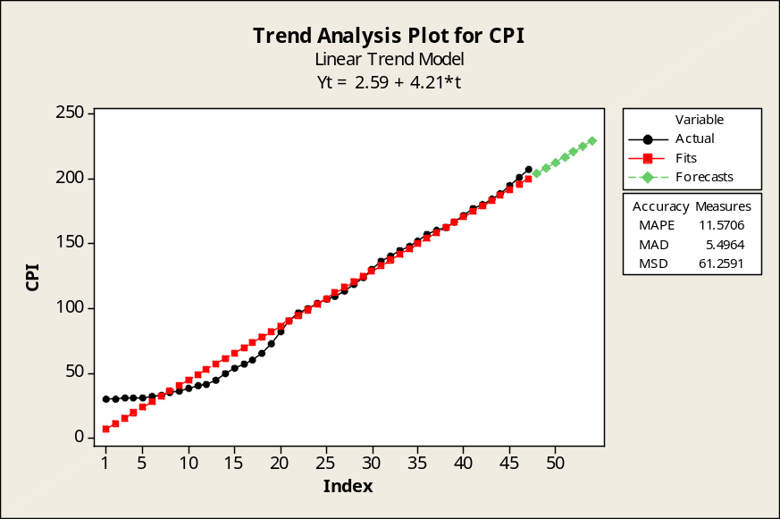

Substituting year codes 51 through 54 into the linear trend equation, we extrapolate to estimate the CPI for 2011 through 2014. Using these estimates the wages would be $21.71 for 2011, $22.13 in 2012, $22.55 in 2013, and $22.97 in 2014.

Year | Year Code | CPI (est.)
2011 | 51 | 217.1
2012 | 52 | 221.3
2013 | 53 | 225.5
2014 | 54 | 229.7

2. The quadratic trend equation, CPI = 14.33 + 2.769*(Year Code) + 0.02994*(Year Code)²,
and MAD = 5.2928.

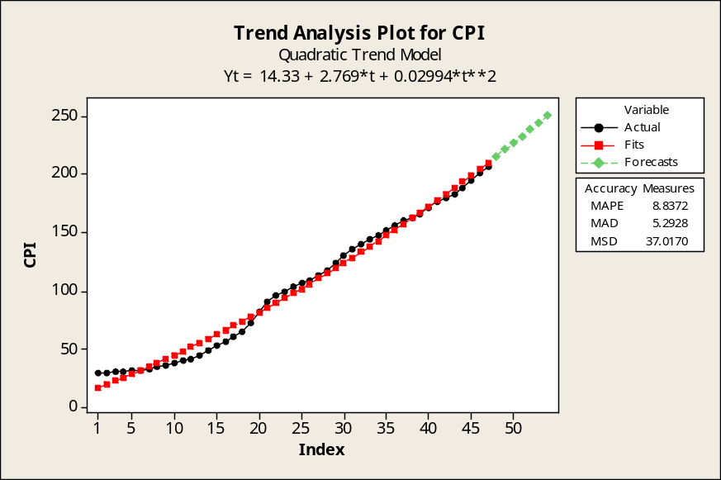

Substituting year codes 51 through 54 into the quadratic trend equation, we extrapolate to estimate the CPI for 2011 through 2014. Using these estimates the wages would be $23.34 for 2011, $23.93 in 2012, $24.52 in 2013, and $25.12 in 2014.

Year | Year Code | CPI (est.)
2011 | 51 | 233.4
2012 | 52 | 239.3
2013 | 53 | 245.2
2014 | 54 | 251.2

3. The Thorndikes would prefer use of the linear equation, and the union would prefer the quadratic equation. For each of the four years, the quadratic trend equation yields a higher hourly wage than the linear trend equation.

4. Using the MAD criterion, the quadratic trend equation is the better fit to the CPI data series.

5. Assuming the hourly wages are linked to the quadratic equation (chosen because of the smaller MAD), employees will be paid $25.12 per hour in 2014. If the estimated CPI of 251.2 actually occurs in 2014, the average Thorndike worker will experience a decrease in real earnings from his 1987 salary of $12.40 per hour to his 2014 salary of $25.12 per hour.

Considering 1987 (CPI = 113.6, average Thorndike worker wage = $12.40) and the estimates for 2014 (CPI = 251.2, average Thorndike worker wage = $25.12): The CPI will have been multiplied by 2.211 during this period, while the average Thorndike worker's wages will have been multiplied by only 2.026. This gives a real earnings index of (2.026/2.211)*100 = 91.6, which implies an 8.4% decline in real earnings.

